**Technical assessment for**

**Waste to Energy**

Sector: Electricity generation

Agency Level: Utilities

Keywords: Municipal Solid Waste, Electricity Generation, Methane, Grid, Renewable Energy Source

Edition 3 (June 2020)

**Prepared by:**

Zak Accuardi, Research Fellow

Erika Boeing, Research Fellow

Tala Daya, Senior Research Fellow

João Pedro Gouveia, Senior Research Fellow



[info@drawdown.org](mailto:info@drawdown.org) [www.drawdown.org](http://www.drawdown.org)

Table of Contents

List of Figures 4

List of Tables 4

Acronyms and Symbols 5

Executive Summary 6

1 Literature Review 8

1.1. State of Waste to Energy Technology 8

1.1.1 Prevalent Locations and Uses 9

1.1.2 Emerging Technologies 9

1.2. Adoption Path 10

1.3 Advantages and disadvantages of Waste to Energy Systems 12

1.3.1 Similar Solutions 12

1.3.2 Arguments for Adoption 13

1.3.3 Additional Benefits and Burdens 13

1.3.4 Comparison to Other Waste Management Options 15

2 Methodology 19

2.1 Introduction 19

2.2 Data Sources 20

2.3 Total Addressable Market 22

2.3.1 Primary TAM of Electricity Generation 22

2.3.2 Secondary TAM for Waste 23

2.4 Adoption Scenarios 24

2.4.1 Waste to Energy Adoption Prognostications – TWh 24

2.4.2 Waste to Energy Adoption Prognostications – Tons of Waste 25

2.4.3 Reference Case / Current Adoption 27

2.4.4 Project Drawdown Scenarios 27

2.5 Inputs 28

2.5.1 Climate Inputs 28

2.5.2 Financial Inputs 33

2.5.3 Technical Inputs 35

2.6 Assumptions 35

2.7 Integration 37

2.8 Limitations / Further Developments 37

3 Results 39

3.1 Adoption 39

3.2 Climate Impacts 40

3.3 Financial Impacts 42

4 Discussion 44

4.1 Sensitivity Analysis 44

4.2 Limitations 45

4.3 Benchmarks 45

5 References 47

6 Glossary 55

# List of Figures

Figure 1.1 Parts of a WTE grate combustion plant (Themelis et al., 2013) 9

Figure 1.2 MSW disposal breakdown by country (IPCC, 2014) 11

Figure 1.3 Hierarchy of solid waste disposal (IPCC, 2014) 16

Figure 1.4 Hierarchy of solid waste disposal (Themelis et al., 2013) 17

Figure 1.5 Hierarchy of solid waste disposal, Hoornweg and Bhada-Tata (2012), Fig. 14 18

Figure 3.1 World Annual Adoption 2015-2060 40

Figure 3.2 World AnnualGreenhouse Gas Emissions Reduction 42

Figure 3.3 Operating Costs Over Time for the three PD scenarios 43

# List of Tables

Table 2.1 Climate Inputs 32

Table 2.2 Financial Inputs for Conventional Technologies 34

Table 2.3 Financial Inputs for Solution 34

Table 2.4 Technical Inputs Conventional Technologies 35

Table 2.5 Technical Inputs Solution 35

Table 3.1 World Adoption of the Solution 39

Table 3.2 Climate Impacts 40

Table 3.3 Impacts on Atmospheric Concentrations of CO2-eq 41

Table 3.4 Financial Impacts 42

Table 4.1 Benchmarks 45

# Acronyms and Symbols

* AMPERE – Assessment of Climate Change Mitigation Pathways and Evaluation of the Robustness of Mitigation Cost Estimates
* BAU – Business as Usual
* CH4 - Methane
* CHP – Combined Heat and Power
* CO – Carbon monoxide
* CO2 – Carbon Dioxide
* DOC - Degradable Organic Carbon
* DS – Degree Scenario
* ETP – Energy Technology Perspectives
* EU – European Union
* GDP – Gross Domestic Product
* GHG – Greenhouse Gases
* Gt – Gigatons
* GW - Gigawatts
* GWP – Global Warming Potential
* H2 - Hydrogen
* IEA – International Energy Agency
* IPCC – Intergovernmental Panel for Climate Change
* IRENA – International Renewable Energy Agency
* LCA – Life Cycle Assessment
* MCF - Methane Correction Factor
* MSW – Municipal Solid Waste
* N2O – Nitrous Oxide
* O&M - Operations and maintenance costs
* OECD – The Organisation for Economic Co-Operation and Development
* PDS - Project Drawdown Scenario
* PPM - Parts per million
* REF- Reference Scenario
* RES – Renewable Energy Sources
* TAM - Total Addressable Market
* TWh - Terawatt-Hours
* UK – United Kingdom
* US – United States
* USD – United States Dollar
* WEO – World Energy Outlook
* WTE – Waste-to-Energy

# Executive Summary

Project Drawdown defines *waste-to-energy* as: the combustion of waste and conversion to electricity and usable heat in waste-to-energy plants. This solution replaces conventional electricity-generating technologies such as coal, oil, and natural gas power plants. *Waste-to-energy* reduces greenhouse gas emissions in many cases, though the magnitude of that reduction varies substantially depending on the baseline used for comparison. Key considerations in *waste-to-energy*’s case include: the caloric content of combusted waste; its methane generation potential (were it to be landfilled); likely alternative waste disposal pathways; and the emissions intensity of electricity and/or heat being displaced by that generated by the waste-to-energy process.

*Waste-to-energy* has seen wide adoption in Europe, the USA, and Japan, and adoption is growing rapidly in China. The Organisation for Economic Co-operation and Development (OECD) countries are most likely to see significant growth in its market penetration moving forward, as the primary barriers to entry for *waste-to-energy* are high capital cost (in part due to high-cost pollution control technologies, which are essential in mitigating potential adverse public health impacts) and the reliable availability of municipal solid waste with a high caloric heating value. *Waste-to-energy* adoption will have the largest climate impact when it displaces both landfill disposal (particularly with low methane capture) and carbon-intensive power generation, i.e. coal, natural gas, and oil combustion. *Waste-to-energy* adoption is presented in two ways: in terawatt-hours of electricity generation, and in tons of waste produced. Both types of presentations are used in our adoption prognostications. The total addressable market for waste-to-energy is based on projected global electricity generation from 2020-2050. Current adoption in 2018 was estimated at 0.38 percent of generation (86.22 terawatt-hours). Adoption data from IRENA Renewable Energy Statistics (2019), the IEA World Energy Outlook (2019) and Energy Technology Perspective (2017), IEEJ Outlook (2019), Equinor Energy Perspective (2018), and Greenpeace (2015)  are used to project current and future adoption. Impacts of increased adoption of waste-to-energy from 2020-2050 were generated based on three growth scenarios, which were assessed in comparison to a Reference Scenario where the solution’s market share was fixed at the current levels.

The Plausible, Drawdown and Optimum Scenarios are generated based on an average of conservative adoption case scenarios informed by the literature referenced above and bounded by available waste from integration allocated to waste to energy solution. This results in a 0.72 percent share of total electricity generation portfolio in 2050 for the Plausible Scenario; 0.34 percent for the Drawdown Scenario; and 0.14 percent for the Optimum Scenario.

The uncertainty associated with the future adoption of *waste-to-energy* is linked to other waste management solutions: *landfill methane capture*, *methane digesters*, *recycling*, and *composting* could affect the balance of available waste for each solution. However, for Project Drawdown, the prioritization of waste management is composting, followed by recycling, followed by waste to energy, and finally landfill methane capture.

The results for the Plausible Scenario show that through advanced global adoption of waste-to-energy from 2020-2050, 147.2 TWh of waste-to-energy plants can be installed globally, increasing the electricity generation market share for this technology from 0.38 percent to 0.72 percent. This will result in the total avoided emissions of 3.09 gigatons of carbon dioxide-equivalent greenhouse gases. The net cost compared to the *Reference* Scenario would be US$95 billion from 2020-50, and around US$33.07 billion in net operating cost for *waste-to-energy* plants over the same period. The climate impacts of the *Drawdown* and *Optimum* Scenarios over 2020-2050 are 5.36 and -1.31gigatons carbon dioxide-equivalent, respectively in comparison to conventional technologies implementation.

While preferable to landfilling, *waste-to-energy* is seen as a “regrets” solution, which is best served as a bridge technology before other preferable waste management options become fully possible. Promotion of *waste-to-energy* will be most successful where waste disposal and electricity costs are high, and where capital is readily available. *Waste-to-energy* should be promoted appropriately in each region’s context, within a broader framework of integrated solid waste management. This is all the more important given the potentially significant public health risk that insufficiently regulated *waste-to-energy* can pose (and has historically posed) to nearby communities. When appropriately strict pollution controls are in place, and when landfilling is a likely waste disposal alternative, *waste-to-energy* will nonetheless continue to provide an opportunity for societally beneficial greenhouse gas emissions reduction. New waste-to-energy research in Europe and the USA is relatively sparse now, as a result of the technology’s maturity. More active research is ongoing, particularly in East Asia. In general, research resources are more heavily allocated to new technologies such as gasification, pyrolysis, and plasma-arc gasification (as opposed to combustion). While these technologies are common in Japan, they have yet to become mainstream in any other part of the world.

# Literature Review

## State of Waste to Energy Technology

Global waste generation today is estimated to be somewhere between 1.8-2.01 billion tons of waste per year and (Hoornweg & Bhada-Tata 2012; Hoornweg *et al*., 2015; Kaza *et al.* 2018) and is expected to increase to about 3.4 billion tons per year in 2050 (Kaza *et al*., 2018). Waste to Energy is one of many technologies which can be used to divert waste from landfills, thus reducing overall emissions from landfilling and producing usable energy.

Waste-to-energy (WTE; incineration; energy from waste) is the process of burning garbage – generally municipal solid waste (MSW) for the purposes of this report, though the process is also common for medical waste disposal – to recover useful energy, either in the form of electricity (generated by a steam turbine) or heat. Waste-to-energy power plants function similarly to a typical coal-fired power plant, and indeed coal or other solid fuels are commonly used to ignite the MSW or add supplemental heat to the combustion process.

The majority of Waste to Energy systems today have three stages (Figure 1.1). First, mixed waste is loaded into a feed hopper and transported into a furnace where the organic material in the waste is fully combusted at high temperatures (900°C -1,200°C). Waste items that are even as large as a big suitcase can be reduced to ash in this combustion process. Second, a heat exchanger captures this heat in order to either be used immediately for district heating purposes or to transfer it to a steam turbine to generate electricity or to cogenerate heat and electricity. Finally, the flue gases are cooled and cleaned in order to remove toxic chemicals including particulate matter, dioxins and furans, and heavy metals before being released into the air. (Themelis *et al.,* 2013).

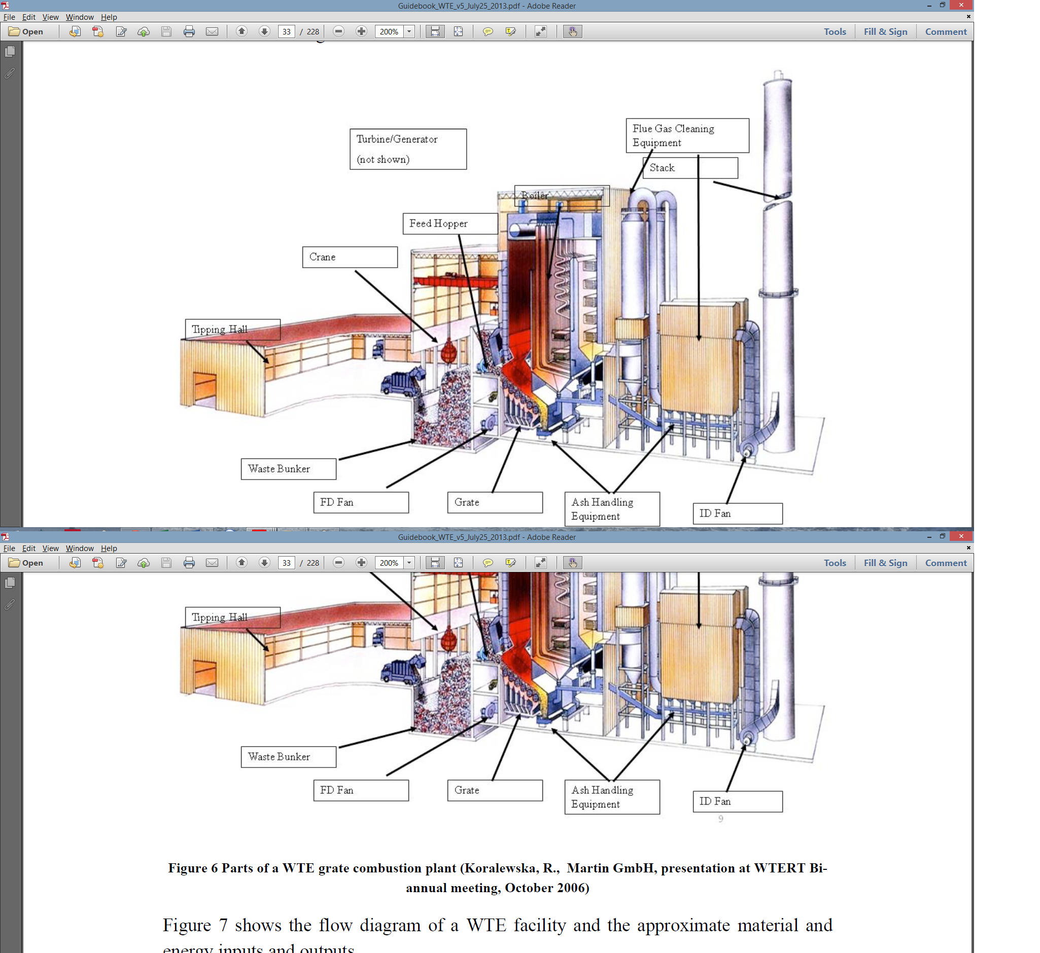

Figure 1.1 Parts of a WTE grate combustion plant (Themelis et al., 2013)

### Prevalent Locations and Uses

Waste to Energy using incineration is a mature technology that has been in widespread use in OECD countries for many decades. Today, WTE has significant penetration in Europe, Japan and the USA. It is also increasingly used in China and East Asia, where WTE is seeing its most rapid market growth (World Energy Council 2013). This rapid growth has been in enabled by supportive government policies (Abdel-Aziz et *al.*, 2014), but may not be wholly desirable – as will be discussed later.

Waste combustion is generally used to generate electricity, though when sufficient demand is available for heat there is also potential for cogeneration applications. This is especially desirable when industrial end users can be collocated with the WTE plant (Themelis et *al*., 2013). Using cogeneration for district heating is also common. In Northern Europe, where the demand for heat is higher, almost all WTE plants are used in a cogeneration or heat only configuration (Reiman, 2012).

### Emerging Technologies

New WTE research in Europe and the USA is relatively sparse now as a result of the technology’s maturity. More active research is ongoing particularly in East Asia. In general, research resources are more heavily allocated to new technologies such as gasification, pyrolysis, and plasma-arc gasification (as opposed to combustion). While these technologies are more common in Japan, they have yet to become mainstream in any other part of the world.

In both pyrolysis and gasification, instead of completely combusting the waste it is partially oxidized under sub-stoichiometric conditions to form an energy-rich gas comprised of hydrocarbons, CO, and H2 (referred to as synthesis gas), which can be cooled, cleaned and combusted in an internal combustion engine or steam turbine to produce electricity and heat. The main difference is that with gasification, some oxygen is added to the system, while in pyrolysis all heat is applied externally and no air is added (Maya et al. 2016). These systems may offer opportunities for lowering costs, overall emissions and increasing overall energy output, but because they have yet to be proven at a commercial scale this is still to be determined (Panepinto *et al*., 2014).

With plasma gasification, waste is still combusted under sub-stoichiometric conditions to form an energy rich synthesis gas which is subsequently combusted in an internal combustion engine. The main difference is that this partial combustion takes place in a plasma torch at minimum temperatures of 2,200°C or higher. At these temperatures, waste components are atomized before combining to form CO and H2, and inorganic materials are melted to form a vitrified slag. The main advantage of plasma gasification is that it can cleanly destroy waste types which are not appropriate for waste to energy plants today, such as hazardous waste. However, in order to reach such high temperatures they typically take as much energy to run as they output, if not more, and the costs required to heat and control plasma are high (*Themelis* et al., 2013). Therefore, this is likely only a viable solution for MSW in limited situations.

Examples of pyrolysis, gasification, and plasma gasification systems operating successfully with MSW today exist, but the technologies have yet to become mainstream. However, with more research and scale up for funding they are all viable technologies which could change the value proposition of the industry.

## Adoption Path

The dearth of WTE-specific literature is relatively unsurprising. The field is largely industry-driven and the merits and limitations of the technology are well understood. New reports may not have much to add with respect to technological changes. This is unfortunate mostly because as a result there is not an easily accessible record of the industry’s growth, current cost information, or relevant regulatory changes.

Some of that information is simply hidden behind industry report paywalls. Three reports tease some of what more may be available, though they are all likely to focus more on possible market opportunities than likely WTE adoption. Grand View Research published the most recent of these, though its ‘report summary’ provides no new information (Grand View Research 2015). A firm called Vision Gain has produced a ten-year market forecast, looking out to 2024 (Vision Gain 2014). Finally, Pike Research (an energy-focused subsidiary of Navigant Research) published its own ten-year outlook a couple years prior, forecasting substantial growth to a waste processing volume of 261 million tons annually through WTE, yielding 283 TWh of electricity and heat generation in 2022 (Navigant Research 2012). Figure 1.2 depicts the breakdown between municipal solid waste disposal by country for landfill, recycling and composting and to waste to energy units.

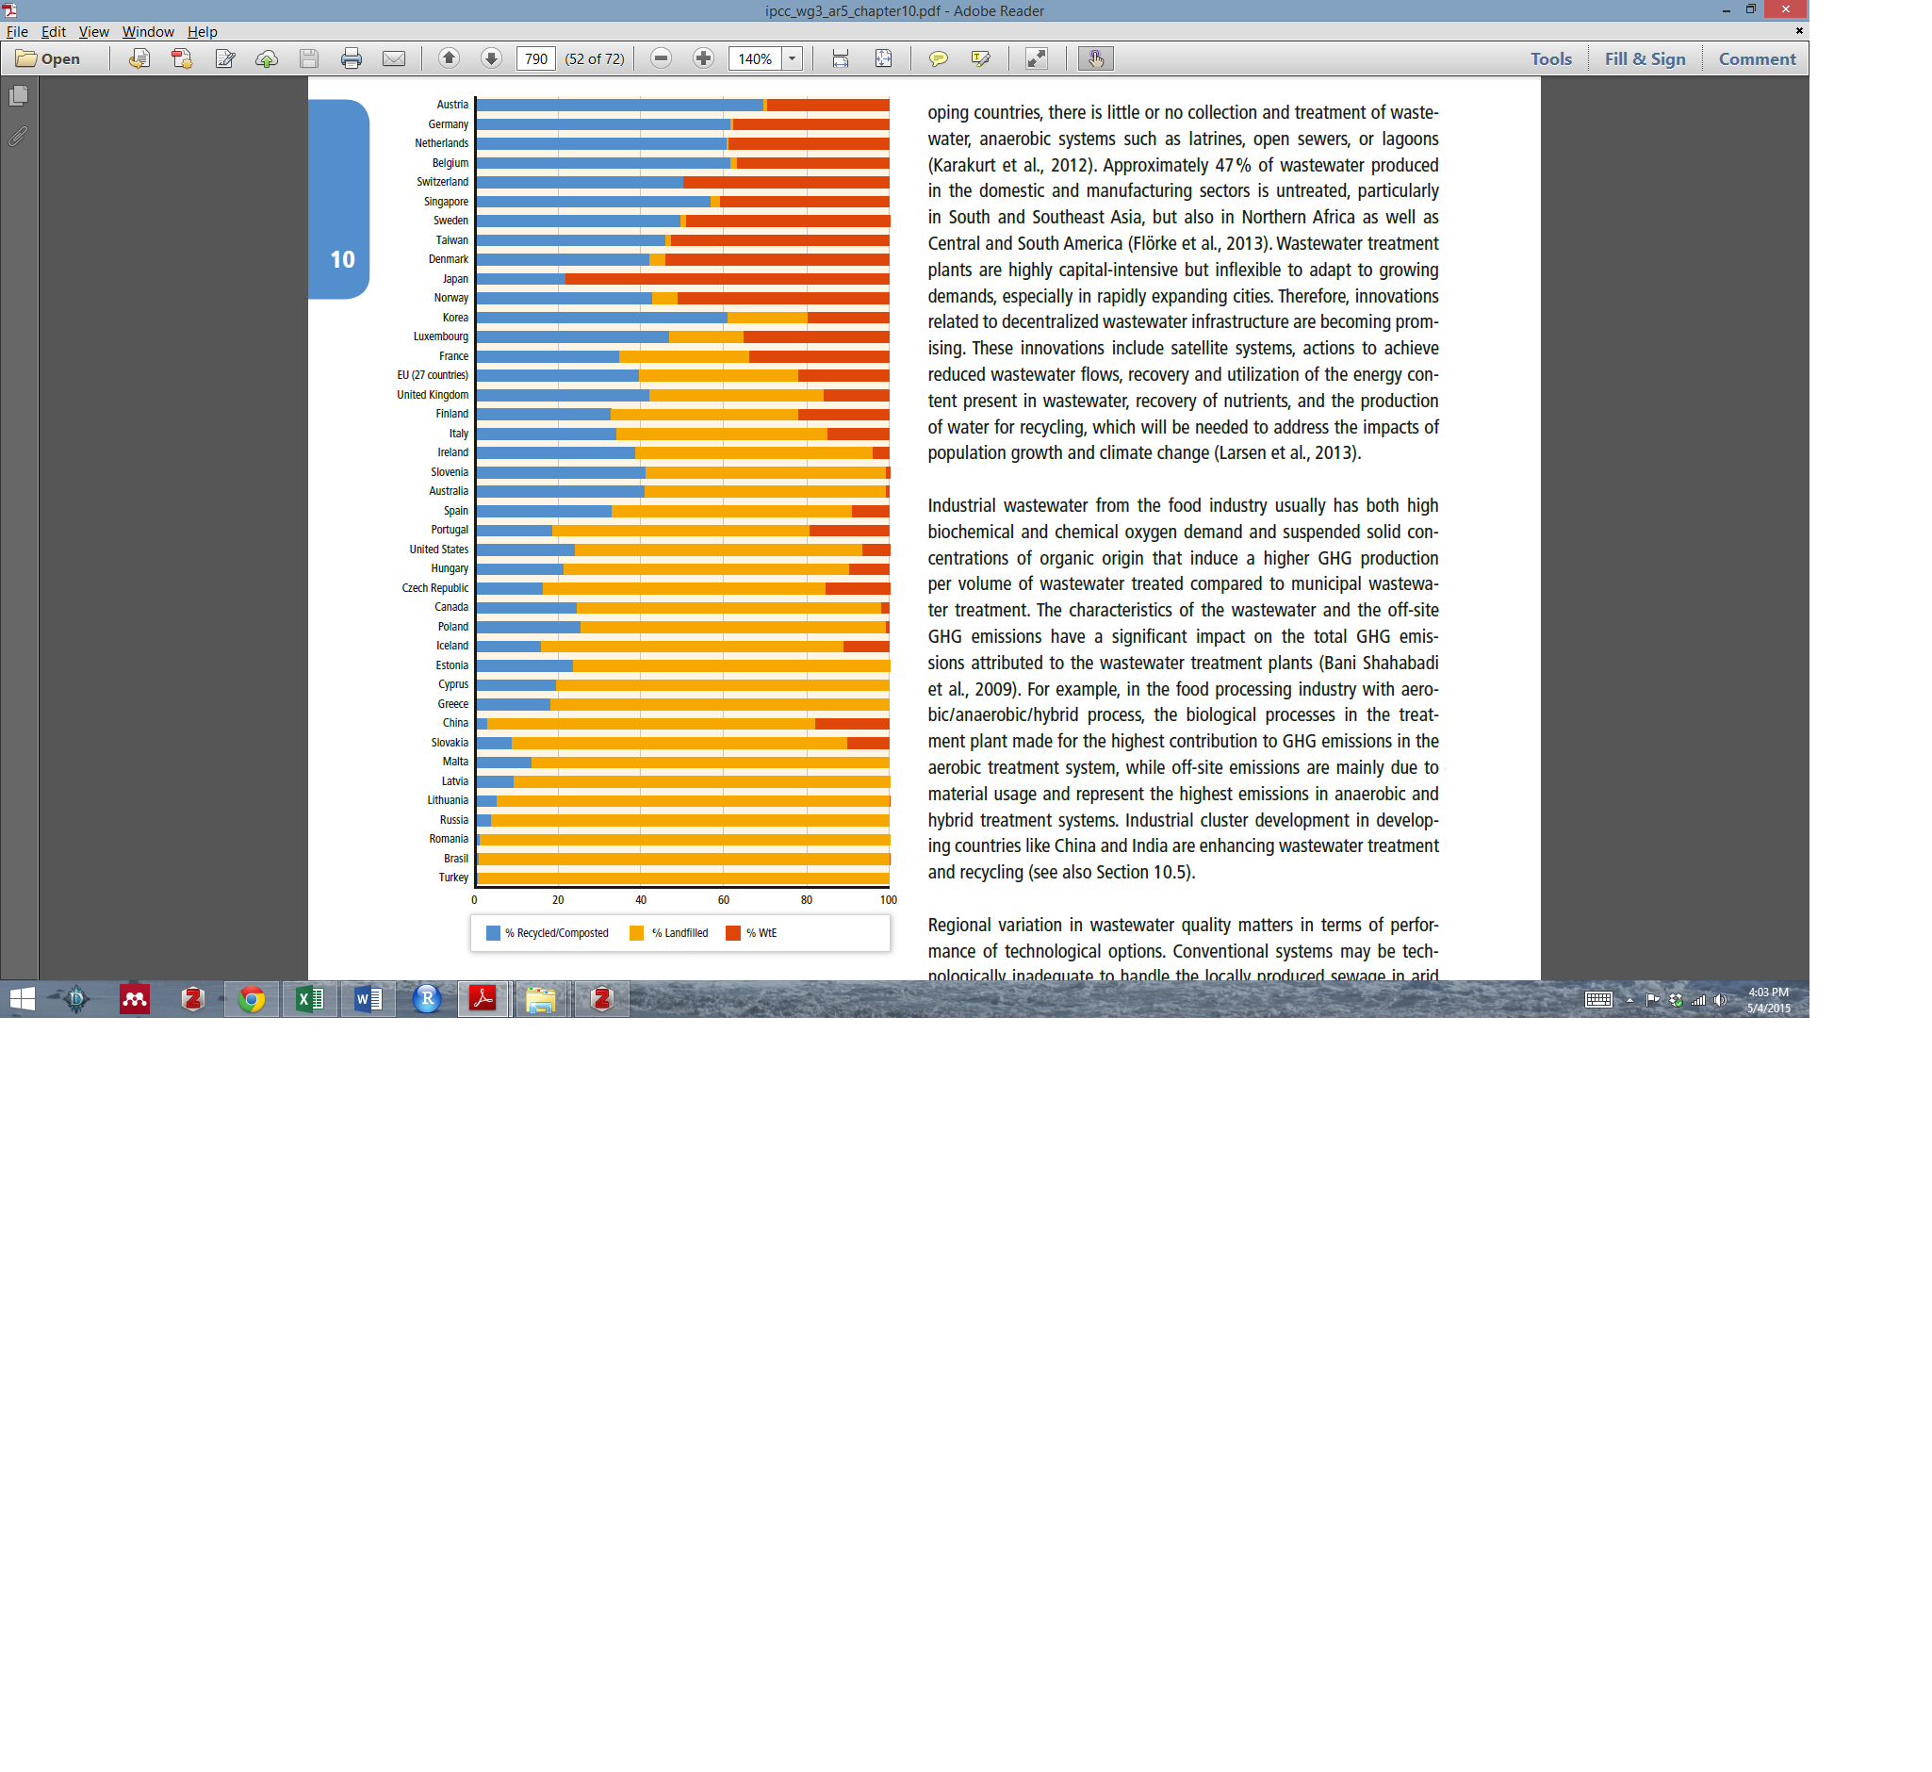

Figure 1.2 MSW disposal breakdown by country (IPCC, 2014)

Besides the rapid, government supported proliferation of WTE in China, the technology is almost absent outside of OECD countries, with major barriers being high capital costs and relatively low waste heating values, which are determined by waste composition. Waste combustion favors dry waste with a high heating value; wet waste streams can make WTE infeasible (Bhada, 2007), and may instead be preferred for use in anaerobic digestion (Funk *et al*., 2013). The energy content of waste tends to be higher in developed countries, and developed countries are also generally more space constrained, which makes landfill avoidance all the more desirable (Monni *et al*., 2006).

All of these factors lead to WTE growth prospects that are concentrated in OECD countries and East Asia. There are more modest prospects in other places, limited by capital cost and dependent on pollution and waste disposal regulations (Themelis *et al*., 2013). The economics of WTE plants are also strongly impacted by regional electricity prices and waste disposal costs.

As of 2007 there were roughly 600 WTE facilities operating worldwide, including about 400 in the EU, more than 100 in Japan, and 88 in the USA (where no new WTE plants have been completed for more than 20 years). In 2010, Modak (2011) estimates that WTE generated 71,600 GWh of power by incinerating 192 million tons of MSW, with total global capacity of 54 GW. Modak predicts that in a BAU scenario, that capacity will grow to 200 GW by 2050, disposing of roughly half a billion tons of waste annually.

One limitation of existing WTE literature describing the technology is that because of the technology maturity and lack of present research, studies are often heavily case-study driven, meaning that any given analysis may focus on a particular type of plant or context and thus may not be scalable. In other words, meta- or macro-analyses are few and far between.

## Advantages and disadvantages of Waste to Energy Systems

### Similar Solutions

There are several solutions in the electricity generation sector that replace conventional electricity-generating technologies such as coal, oil, and natural gas power plants, and that could be considered similar solutions. While preferable to landfilling, waste-to-energy is seen as a second-best technology, which is best served as a bridge technology before other preferable waste management options become fully possible. Advantages and disadvantages of WTE are discussed below in a general sense, and then in comparison to other waste management options.

### Arguments for Adoption

Despite the many disadvantages described above, WTE also offers substantial benefits, starting with its greenhouse gas emissions reduction potential. WTE’s greenhouse gas impact comes first from reduced methane emissions due to landfill decomposition, and second from the displacement of energy from other less-sustainable sources. When WTE is used to generate electricity – and depending on the waste stream’s composition – nearly two-thirds of the electricity can be attributed to the combustion of biomass (Themelis *et al.*, 2013). In some countries, and to varying degrees, this has resulted in WTE’s classification as a renewable (or partially renewable) energy source. Furthermore, WTE is able to recover energy from high-energy materials such as plastics, which would not be recovered even in a landfill methane gas to electricity system.

Additionally, as part of the process, WTE plants commonly recover some of the ferrous and non-ferrous metals in the waste stream, which is typically sold to create a small revenue stream. While this is still less desirable than direct recycling, it offers an opportunity for material recovery when direct recycling is not done.

The reduction in volume of waste being sent to landfill is also particularly useful in land-constrained regions. This highlights the fact that as a localized treatment method, WTE can reduce emissions from the transportation of waste. This is especially valuable when truck-based transport distances are significant. At a more granular level, however, increased truck traffic to a WTE plant can create higher pollution concentrations in the plant’s immediate vicinity; typically, however, this is more or less equivalent to the amount of truck traffic that would be required to support a MSW disposal substation.

### Additional Benefits and Burdens

WTE has some unsavory history around toxicity, which is still one of its greatest criticisms today. Absent very strong pollution control and treatment systems, waste incineration generates toxic emissions with, among other pollutants, a high concentration of cancer-causing dioxins and furans. In a life-cycle comparison of composting, anaerobic digestion, and incineration, Di Maria and Micale (2015) found, for example, that incineration outperforms these alternatives in all categories except toxicity – for which incineration is the worst performer.

Organizations like GAIA (Global Alliance for Incinerator Alternatives, founded in 2000) have sprung up since the 1980s to oppose the use of incinerators for this and several other reasons (see, e.g. Global Alliance for Incinerator Alternatives, 2014). Not only are emissions high, they claim, but WTE facilities are likely to be sited in or near dense urban areas where a sufficient and reliable supply of municipal solid waste is available. This increases the importance of public health concerns when considering the technology’s adoption path.

Still, much of the evidence suggests that the induced cancer risk from WTE plants is small when they are outfitted with *modern* pollution control technology. A study by the UK Health Protection Agency found that the cancer risk from exposure to pollution from WTE plants is “very small”, with evidence to the contrary coming from research on outdated technologies (Health Protection Agency 2009). It is important to note that this may not hold true for many of the WTE plants constructed in China for a fraction of the capital cost that would be expected in the US or EU, particularly when that capital cost reduction is enabled by less stringent pollution control regulations. For the purposes of this analysis, we will only consider modern, higher cost plants with advanced pollution control systems, and public health impacts should be a primary consideration in promoting WTE.

Another disadvantage of waste to energy is in the components of the waste which remain after combustion. In particular, bottom and fly ash are two byproducts of the waste incineration process – they comprise the components of the MSW stream that are not combustible. Bottom ash is relatively inert, but fly ash is a highly toxic substance and must be stabilized properly before landfill disposal to prevent highly concentrated toxicity hazards. This is a well-established practice but is expensive. All told, bottom and fly ash typically represent about 20% of the mass of waste entering the WTE facility, and an even lower percentage by volume. When they are ultimately sent to landfill, they do not decay into methane like MSW would, since nearly all of the waste-bound carbon has already been combusted.

WTE critics highlight a potential tension between WTE and other waste disposal methods, in particular recycling. An important consideration of WTE viability is the caloric content of the local waste stream, which is influenced substantially by the amount of fossil carbon in the form of plastics and other petroleum-derived products. If more of these products are recycled, WTE facilities are able to produce less electricity or heat. This is not necessarily a deal breaker, and WTE proponents commonly point to examples of cities (and countries) where recycling and WTE rates are both high (Themelis *et al*., 2013). It is also often argued that WTE is a prime option to treat post-recycling waste or waste streams which are no longer fit for recycling.

In the developing world, labor impacts can also be an important consideration. Informal and small-scale waste management networks are threatened by the expansion of centralized collection and treatment in the form of WTE or otherwise. The Global Alliance of Waste Pickers is a collaboration of waste picker organizations from across the world, including India, Latin America, and Africa. They are actively vocal against incinerators and landfill gas to electricity systems, stating that they reduce the environmental benefits that waste pickers bring from recycling and pose an ethical problem of taking away the jobs of waste pickers. Instead, they promote subsidies for better recycling practices (see: e.g. Global Alliance of Waste Pickers, 2014).

Another significant disadvantage of waste-to-energy is cost. By comparison, sanitary landfill capital costs are roughly 30% that of WTE, which often makes it a more attractive option in the developing world (Themelis and Ulloa 2007). Looking at the potential for WTE adoption in Latin America, for example, Themelis et al. (2013) conclude that the technology is generally not economically feasible absent governmental subsidy at present. The same is likely to be true in most developing countries. Therefore, even though WTE technologies generally pay themselves back within their lifetimes, if there is limited upfront money for waste management or other environmental initiatives, the very large upfront expense of WTE compared to its environmental benefits makes one question whether money would better be spent on something else.

Finally, there are some context-specific considerations for WTE that are difficult to capture in a model like this – for example, air pollution from garbage trucks, the potential for bad smells, and locational considerations for the WTE plants themselves. With respect to the trucks, they too should be minimally polluting to minimize climate and public health impacts alike (for the purposes of this model, we assume their emissions are equal in BAU and OPT scenarios). The same considerations apply to their routing and regulation as would apply to trucks serving a landfill – though landfills are likely to be sited further from city centers, so their associated waste transportation emissions may in fact be higher. With respect to smell, the WTE plants themselves commonly utilize negative pressure to minimize odor outside the plant (trucks are another story; though again, this challenge is no different from landfill BAU). Finally, power plant siting can negatively impact communities, and the same considerations that would be necessary for other power plant types should be applied for WTE as well.

### Comparison to Other Waste Management Options

The impact of WTE will vary fairly substantially by region, but perhaps the two most influential factors in the climate impact of WTE include (1) what alternative waste disposal method is WTE displacing; and (2) what type of electricity production is WTE displacing? (Eriksson et al. 2007).

Generally speaking, from a climate change and environmental impacts perspective, incineration is preferable to landfilling (even accounting for landfill gas recovery, in many cases) but not to recycling or composting (Cherubini et al. 2009). This landfill < WTE < recycling/composting hierarchy is preserved independently of studies’ time horizon (Moberg et al. 2005; Finnveden et al. 2000). This is not necessarily the case for every individual material type, however, highlighting the potential value of waste sorting.

If recycling is not a viable alternative, implementing a policy that promotes incineration is generally better than promoting landfilling. However, incineration may lead to increase emissions of green house gases in a short-time perspective in comparison to landfilling of materials which are not easily degradable such as plastics and some constituents of paper materials (Finnveden *et al.*, 2000).

Organizations like the aforementioned GAIA argue that WTE is less preferable to landfilling, though the bulk of scientific evidence seems to contradict their position. One analysis that is conspicuously absent from the literature would compare climate and public health impacts under varying regulatory scenarios. There does seem to be an important climate change and public health trade-off when regulations are weak, but the magnitude of the trade-off does not appear to be thoroughly understood.

This conventional wisdom is institutionalized in the hierarchy of solid waste disposal, which is typically discussed as if there is only one of them – however, as discussed above, there is not quite such a broad consensus. Below are three versions of this hierarchy:

The first, from the IPCC, places energy recovery above all forms of landfilling, but states that landfill methane recovery and use is preferable to incineration when no energy is recovered (Figure 1.3) is also worth noting that the segment labeled as Energy Recovery is defined as both waste to energy and anaerobic digestion, and treatment without energy recovery includes both incineration and composting. The IPCC report also states that while this hierarchy can be used as general guidance, priorities are likely to change based on waste composition and local circumstances. This is the only hierarchy in which composting is placed below waste to energy.



Figure 1.3 Hierarchy of solid waste disposal (IPCC, 2014)

The second figure places waste to energy squarely and separately above all landfill options (Figure 1.4). Unlike the first figure it places composting above waste to energy. However, the report also acknowledges that these are just guidelines and that the order may change based on local conditions. As one example, the report states that using green waste as a cover in landfills can be environmentally preferable to composting (and therefore to waste to energy as well). The hierarchy also does not specify which types of aerobic and anaerobic composting it is referring to, which can make a big difference.

As one example, it is commonly argued that if biomass materials were habitually composted rather than sent to the landfill, very little methane would be emitted from a landfill as the majority of landfill methane comes from biomass. With aerobic composting this is certainly the case, but many composting sites can cause anaerobic breakdown of the waste and also emit methane. Some larger sites even capture it and use it to generate electricity for their facility (Powell *et al.,* 2016). This may be the type of anaerobic composting referred to in this study.

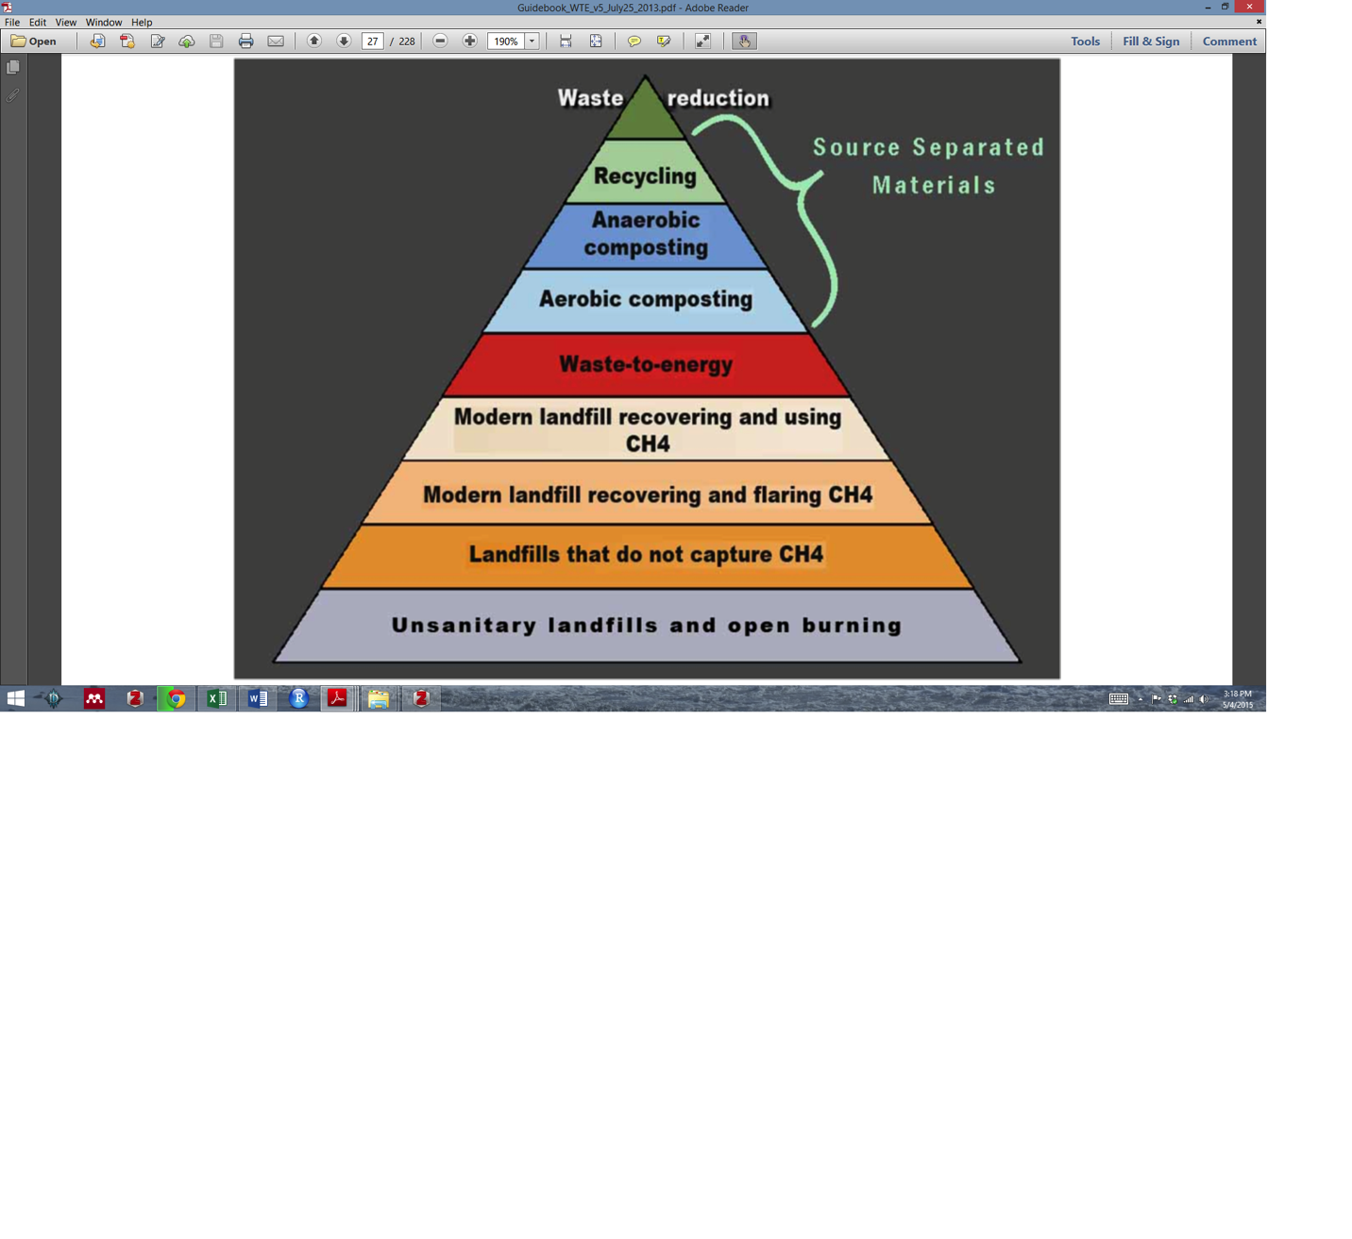

Figure 1.4 Hierarchy of solid waste disposal (Themelis et al., 2013)

The third hierarchy from the World Bank’s 2012 What a Waste report is slightly less clear, and places landfill above incineration, though only by a dotted line (Figure 1.5). Furthermore the text description of this hierarchy in the report states that recovering the energy value embedded in the waste prior to disposal is preferable to landfilling. It also states that aerobic composting and anaerobic digestion should be placed above waste to energy, but that production of uncaptured methane in composting should be avoided.

While there are slight variations in the preferences of each of the hierarchies above, the general hierarchy makes it clear that waste to energy is a second-best waste management strategy, even though it can have substantial benefits. The slight discrepancies between these hierarchies also make it clear that when choosing between two waste management options close to each other on the hierarchy (for waste to energy this would be landfill with/without energy recovery and some forms of composting), the decision should be made based on an analysis of local conditions, waste composition and the specific version of the waste management practice proposed.

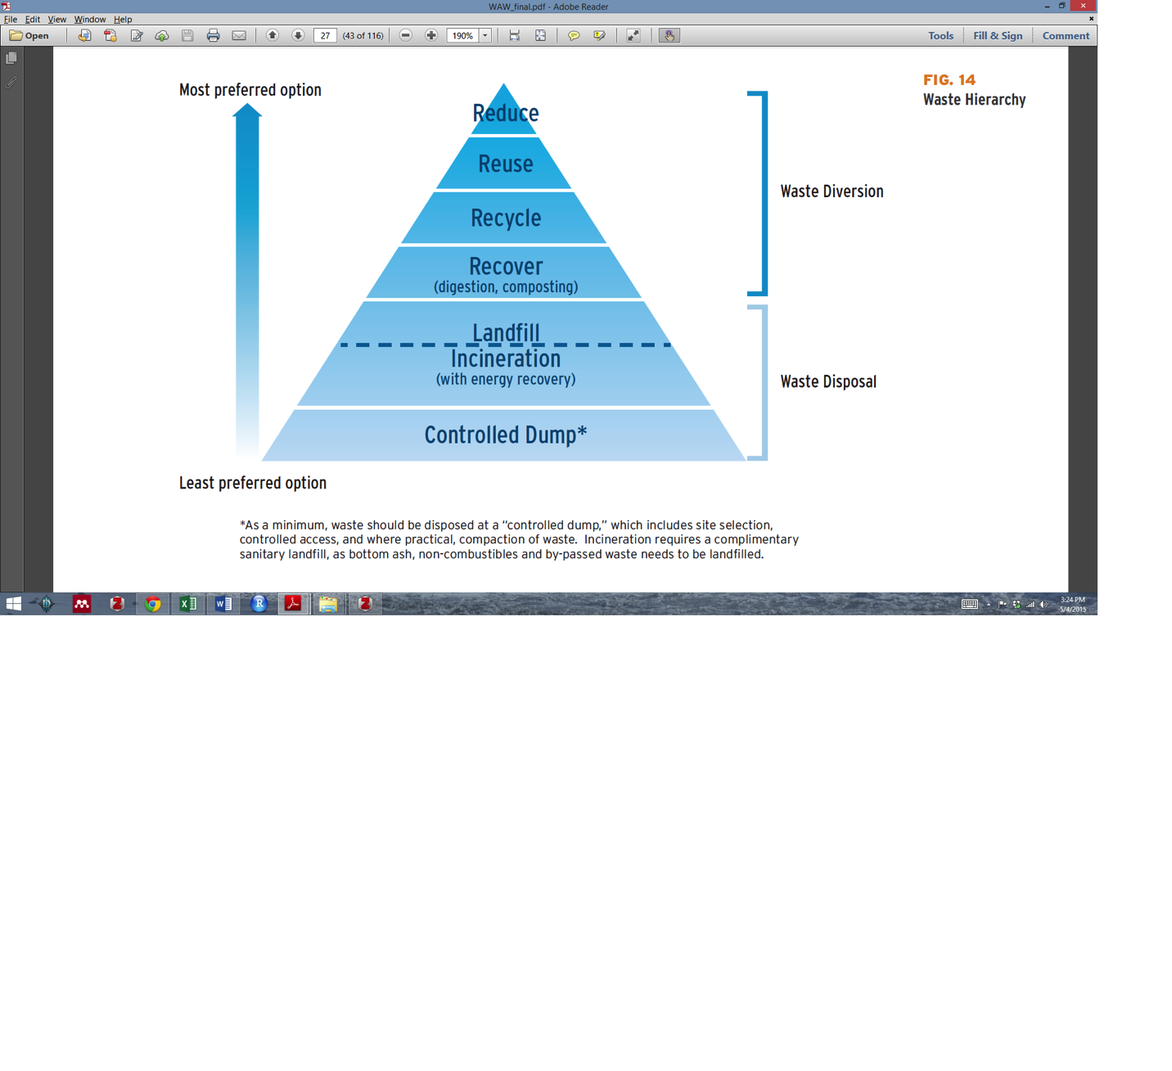

Figure 1.5 Hierarchy of solid waste disposal, Hoornweg and Bhada-Tata (2012), Fig. 14

In general these hierarchies also suggest that Waste-to-Energy’s proponents’ arguments live or die on the assumption that some landfill-bound MSW is unavoidable. As progressive cities begin to more aggressively pursue zero-waste strategies, this assumption will be tested. If one thinks of WTE as a “bridge” to a zero-waste disposal system, much as natural gas is discussed as a low-carbon “bridge” fuel, then WTE is quite an expensive bridge – but one that will likely still provide a good waste management option in countries where investors can afford it.

# Methodology

## Introduction

Project Drawdown’s models are developed in Microsoft Excel using standard templates that allow easier integration since integration is critical to the bottom-up approach used. The template used for this solution was the Reduction and Replacement Solutions (RRS) which accounts for replacement of conventional electricity generation technologies (*i.e.* coal, oil, natural gas) and related emissions for an alternative solution (see the Drawdown RRS Model Framework and Guide for more details). These technologies are assumed to compete in markets to supply the final functional demand which is exogenous to the model, but may be shared across several solution models. The adoption and markets are therefore defined in terms of functional units (TWh), and for investment costing, adoptions are also converted to implementation units (TW). The adoptions of both conventional and solution were projected for each of several scenarios from 2015 to 2050 and the comparison of these scenarios (for the 2020-2050 segment) is what constitutes the results.

For this solution, the approach was to analyze the climate and financial impacts of increased adoption of waste to energy systems for electricity generation. The model used for this analysis constructs both alternative ambitious adoption pathways (PD scenarios) and a Reference scenario (REF) for WTE systems. Following project Drawdown methodological assumption (further description available on the Drawdown RRS Model Framework and Guide), in order to grasp the total impact of an increased adoption of the solution during the assessed time frame; the REF scenario assumes future adoption of waste to energy remains fixed at the current base-year (i.e. 2018) percentage of Total Addressable Market (TAM), estimated at 0.38 percent of generation (86.2 terawatt-hours). The TAM for this solution is based on the common Pproject Drawdown projected global electricity generation in terawatt-hours till 2050 (Section 2.3.).

The developed alternative PD scenarios, draw on existing adoption scenarios for biomass and waste driven by distinct climate mitigation expectations to model several alternative adoptions. The RRS model contains both financial and climate analyses in order to model the global and regional impacts of adoption in the PDS scenarios compared to the REF scenario. What the model thus prognosticates is the total financial costs and benefits of adoption cases for waste to energy solution, as well as the contribution this adoption can make to annual and cumulative emissions reduction.

## Data Sources

This section presents key data sources utilized in the model to evaluate the adoption of waste to energy technologies. Data inputs for the model come from a variety of sources, primarily from peer-reviewed publications and from institutional reports. For all variable inputs, it was done a variable meta-analysis of existing literature to create low, high, and mean estimates. For each solution variable, it is conducted a sensitivity analysis of, on average, ten data points reported in the literature and in some cases as many as 21. This allows to calculate robust and reliable inputs for the financial, technological and climate analyses that represent both optimistic and conservative estimates for the future costs and benefits of adopting this solution.

Several sources for financial inputs were used, such as, a report from the World Energy Council and Bloomberg New Energy Finance. This report gives comparative costs from producing electricity from a large variety of conventional and unconventional energy sources, including first cost values for waste to energy in Europe and the US (World Energy Council, 2013). Second, UN Environment Program’s 2015 Global Waste Management Outlook gives typical ‘investment costs’ for waste to energy. It was also uses the values presented in IRENA’s Renewable Energy Technologies: Cost Analysis Series, where they cite a presentation by O’Connor in 2011 (IRENA, 2012). The US Energy Information Administration (EIA) produced studies in 2010 and 2013 comparing capital and operating costs of different electricity generation methods. Herein, their 2013 number was included (U.S. EIA 2013). Finally, cost estimates are also taken from Ragnauth et al. (2013), from a Danish Energy Agency figure that was cited in an energinet.dk report (2012), from dissertation from the University of Rostock (Pfaff-Simoneit ,2012), Lappeenranta University of Technology and Energy Watch Group (Ram *et al*, 2019), and from US DOE Waste to Energy from Municipal Solid Wastes Report (2019).

About half of these sources give their first cost figures in terms of $/kW capacity (World Energy Council 2013; Energinet.dk 2012; U.S. EIA 2013; IRENA 2012; Ram *et al.* 2019; DOE 2019). The other half give their figures in terms of $/ton capacity (UNEP 2015; Pfaff-Simoneit 2012; Ragnauth *et al*., 2013). In analyzing these figures, it was found that the numbers given in $/ton capacity were extremely variable, likely due to different assumptions in waste composition and therefore the total energy capacity of these systems. Therefore, while both numbers are tracked in the model, only numbers given in $/kW are averaged to determine the final first cost estimate.

Variable operating cost estimates are taken from several of the same sources which report first cost (U.S. EIA 2013; Energinet.dk, 2012, Ram *et al.* 2019). In addition, variable operating cost estimates are given in a paper studying specific costs of a Croatian WTE plant (Schneider et al., 2010). In the case of variable operating costs values given in $/ton and $/kWh are very similar when converting between the two metrics, and therefore all values are used in the estimates.

Technical parameters used in the model for the financial calculations such as average annual use and lifetime capacity are retrieved from several of the same reports (Energinet.dk, 2012; Ragnauth *et al*., 2013; Schneider *et al*., 2010; U.S. EIA, 2014; Ram *et al.* 2019) as well as several others (Funk et al., 2013; World Energy Council, 2013b; IRENA, 2016).

Avoided climate impacts of Waste to Energy come from two sources. First, emissions are reduced by displacing fossil fuels with the electricity generation from waste to energy. This is calculated in the RRS model using the same estimates for current emissions from electricity generation mix used in all other electricity replacement solutions.

The second emissions reduction impact is generated from the displacement of CH4 and CO2 from landfills. Estimates for this are described in the adoption scenarios below. The following method is used:

* 1. Calculate Amount of Carbon in Waste
     1. As a prerequisite to estimating the avoided methane emissions from landfill, the carbon in MSW streams is estimated using data from the IPCC waste guidelines on the carbon content of waste types (IPCC, 2006b)
     2. The Degradable Organic Carbon (DOC) fraction is taken from the value calculated for each year given the estimates of the PD scenarios waste composition for after integration. The values for carbon content of each type of waste referenced above are multiplied by the percentage of each type of waste to get an overall DOC fraction.
     3. The average Lower Heating Value (LHV) is taken for each year given the estimate of the PD scenarios waste composition after integration. The values for LHV of each type of waste references above are multiplied by the percentage of each type of waste to get an overall LHV per year.
  2. Avoided methane from waste decomposition (see: IPCC guidelines, below)
     1. Methane emissions are calculated on a global scale, in line with the IPCC waste guidelines using a first order decay model. IPCC default values for methane generation factors are used across the board, and the solid waste disposal emissions guidelines should be reviewed for a detailed explanation of the methodology (IPCC 2007a).
  3. Avoided CO2 from waste decomposition
     1. The same IPCC values used in the calculation of methane emissions are used to calculate total CO2 emitted by landfills (IPCC, 2007a). While this CO2 may be also created in burning of waste in WTE (see discussion on this later), it is calculated in the model for comparison purposes.
  4. Emissions released in burning of waste
     1. CO2, CH4, and N2O released by incineration of waste is calculated using the default IPCC values for burning biomass and non-biomass waste, given in table 2.2 of their 2006 guidelines, chapter 2, volume 2 (IPCC 2006c).

In addition, a few other reports were used in the model to verify the calculations and add more rigor to the emission reduction impacts. These reports included a report from the Technical University of Denmark on Waste to Energy the carbon perspective (Christensen *et al*. 2015), a research article for Carbon Management Journal on the potential of waste-to-energy in reducing GHG emissions (Chandel *et al.* 2012), US EPA report on Air Emissions from MSW Combustion Facilities (2005), and US EPA Inventory of US GHG Emissions and Sinks: 190-2018 (2018).

## Total Addressable Market

### Primary TAM of Electricity Generation

Solutions assessed in the Electricity Generation Sector share a common market for future adoption defined by the total terawatt-hours (TWh) of generation demanded from 2015-2060. This shared total addressable market (TAM) is used to bound this sector technologies rollout over time. The TAM is determined based on the assessment of estimations of current and future electricity generation from a combination of models and scenarios from different sources, including Greenpeace (2015); International Energy Agency (IEA) - Energy Technology Perspectives (IEA, 2017); IEA World Energy Outlook (WEO) (IEA, 2018); Equinor (2018); Ecofys (2018); The Institute of Energy Economics Japan (IEEJ) Outlook 2019 (2018) and Ram et al. (2019). See Project Drawdown report - Assessing the Total Addressable Market and Major Assumptions for more details on the methodology used to develop the electricity TAM. The updated 2019 study follows the same methodological approach with the inclusion of newer sources.

Four prognostications of the TAM for this assessment were derived by using comparable scenarios from each of the above-mentioned sources which were categorized by expected climate mitigation scenarios (i.e. Ambitious, Conservative, and Baseline) and the scale of deployment of renewable energy sources (RES) (i.e. 100% RES scenarios). The sources used mostly provide results at a decadal level, which were interpolated to provide annual values for Project Drawdown calculations.

The Ambitious Project Drawdown TAM Scenario is constructed from the average of yearly values of four scenarios: the IEA (2017) 2D Scenario, the IEA (2017) B2D scenario, Renewal Scenario from Equinor (2018), and IEA (2018) WEO SD scenario. The Conservative Project Drawdown TAM Scenario follows the average yearly values of the IEA (2018) WEO New Policy scenario (NPS); Reform Scenario from Equinor. (2018), IEEJ Outlook (2018) Advanced Tech scenario, and IRENA (2019) Roadmap 2050 REmap case. The Baseline Project Drawdown TAM Scenario is built by the average of the Equinor (2018) Rivalry Scenario, IEEJ Outlook (2018) Reference Scenario, IEA (2017) Reference Case and IEA (2018) WEO Current polices Scenario (CPS). These three Project Drawdown TAM scenarios show an estimated range of electricity generation from 45,286TWh to 49,706TWh by 2050. Baseline TAM is used for PD Plausible scenario assessment.

An ambitious TAM scenario for a 100% RES by 2050, which is aligned to Project Drawdown Optimum and Drawdown scenarios, and utilizes the Greenpeace (2015) Advanced [R]evolution Scenario, Ram *et al.* (2019) analysis and Ecofys (2018) 1.5ºC degree scenario were considered. The estimated electricity generation for this TAM reaches 70,942 TWh by 2050.

### Secondary TAM for Waste

While the RRS model is used and the primary TAM is based on electricity generation, the waste to energy adoption parameters are also limited by the total waste available for use in waste to energy. Therefore, amount of waste can be seen as a “secondary” TAM.

In our model, the Waste TAM consists of a comprehensive global forecast of municipal solid waste (MSW) generation. The waste generation data is a blended solution which takes the average of 4 different waste to energy sources, common to all Drawdown waste solutions. The IEA Annex 1 (IEA 2016) is taken by interpolating from the regional waste estimates for 2013 and 2050. World Bank’s What a Waste 2.0 (2016) reports global waste for 2016 and projections for 2030, and 2050 which are interpolated and extrapolated to make future projections used as a second reference. Some of the same authors from the World Bank report produced another set of future waste prognostications in 2015, which are also used as a source (Hoornweg *et al.*, 2015). Finally, a UNEP 2015 report on Global Waste Management Outlook is used to generate MSW generation per capita, which is multiplied by UN total urban population projections.

The Waste TAM described represents the Pre-Integration MSW. It is then fractionated into an organic fraction of total MSW, a recyclable fraction that includes household & commercial recycling and recycled paper, and a remainder fraction that are then allocated to each material solution based on relevance and prioritization.

Based on the calculated markets for *composting, household & commercial recycling,* and *recycled paper*, the impact of each solution is quantified according to the following prioritization:

1.     *Reduced food waste*

2.     *Bioplastic*

3.     *Composting*

4.     *Household and Commercial (HH&C)* *recycling*

5.     *Recycled paper*

6.     *Waste-to-energy solutions :*

1. Waste to Energy

2. Landfill Methane Capture

This structure of prioritization ensures that quantities are allocated to each solution appropriately, without exceeding feedstock limitations or double counting.

## Adoption Scenarios

Waste to Energy adoption is presented in literature in two ways: in TWh of electricity and in tons of waste. Both types of sources are used in our adoption prognostications. These sources, and the method used to convert between tons of waste and TWh electricity is described below.

### Waste to Energy Adoption Prognostications – TWh

For the alternative global adoption scenarios, we selected six sources that provided results from Biomass and Waste: International Energy Agency (IEA) Energy Technologies Perspectives (2017) and IEA World Energy Outlook (2018), The Institute of Energy Economics Japan Outlook (2019), Equinor Energy Perspective (2018), and Greenpeace Energy Revolution (2015). From these, 14 different scenarios were included to show a wide range of results projecting the role of waste to energy technologies on the future global electricity generation mix. These assessments relate specifically to different climate mitigation pathways or RES adoption. These sources do not clearly depict waste to energy technologies for electricity generation adoption pathways. Their results combine biomass and waste for electricity generation. Thus a few assumptions were considered to obtain future adoption:

1. Current historical global adoption share of renewable waste in all Bioenergy for electricity generation was calculated from IRENA Renewable Energy Statistics (2019) and averaged over the years 2014-2017, and equal to 10.9%. Renewable waste is defined as waste which comes from biomass sources (i.e. food, paper, cardboard, etc.). Under the assumption that 60% of the energy content in waste is from renewable sources, the total share of electricity from waste to energy in all bioenergy is normalized to be 17.2%.
2. Since no better information is available for waste to energy for electricity generation, future adoption was obtained applying the previous calculated share of waste to energy of total bioenergy for global and applied to the results of the sources and scenarios mentioned above.

The uncertainty associated with the future adoption of waste to energy is linked to other waste management solutions as among others, landfill methane capture, methane bio digesters, recycling or composting that could affect the balance between the available waste for each solution.

In order to build the Drawdown Scenarios for waste to energy electricity generation, several data considerations and assumptions were made.

1. It were harmonized all the results of electricity generation from the sources using electricity per capita for the 2015 revision of the United Nations population projections (UNDESA, 2015).
2. The results from the different sources are given for every 5 or 10 years. To determine annual generation values, data interpolation methods were used to create best fit trends (i.e. 3rd polynomial trends applied between reported data).

### Waste to Energy Adoption Prognostications – Tons of Waste

In order to compare the waste scenarios allocated to waste to energy from the Waste integration model to the electricity-based scenarios and to the overall electricity generation TAM, values given in tons of waste were converted to TWh of electricity produced from WTE plants. This can be done using three variables: waste composition, waste heating values, and waste to energy efficiency.

Waste composition prognostications are taken from estimates of composition remaining for waste to energy given PD adoption of other waste-related solutions. Heating values are critical for translating tons of waste to energy output potential for WTE. However, reported heating values vary wildly between different sources, and many sources do not specify whether they are using the lower or higher heating value. Here, it was only used data that specifically calls out the fact that it is used lower heating value. Here, it is taken the average of the heating values from three different sources: The World Bank Technical Guidance Report, a report by the Energy Information Agency focused on describing the allocation of the waste stream to biogenic and non-biogenic, and a thesis from Columbia university investigating WTE feasibility in India (World Bank 1999; EIA 2007; Bhada 2007). Heating values are given based on the type of waste that is used. These are then multiplied by the percentages of each type of waste calculated from the composition data to estimate the total kWh per kg potential of a given waste stream. The numbers presented from these three studies vary widely, and have a large effect when doing a sensitivity analysis. However, there are many studies which estimate a total kWh/kg heating value for the entire waste stream at close to the average of these values, so despite the variation, the average value may still be close to reality.

Efficiency data is key in translating between kWh potential in the waste to kWh WTE output. Efficiency data is unfortunately typically only found in regional studies or case studies of a single plant. These case studies are often in OECD countries, as this is the main location where WTE is concentrated today. While efficiency may vary with waste composition, most studies report it as a single number. In the model, we take an average of all values, ignoring one outlier of 13% which is well below other estimates. This gives us an average net efficiency value of 23.67%.

The multiple scenarios abovementioned described were grouped in the RRS Project Drawdown model to be included under the following cases for analysis:

* *Reference Cases:* represent scenarios where current policies remained fixed over time. The scenarios included here are the IEA WEO Current Policies Scenario (2019), IEEJ Outlook Reference Scenario and No Coal Plants Scenario (2019), Greenpeace Global Reference Scenario (2015), and Equinor Rivalry Scenario (2018).
* *Conservative Cases:* represent conservative emissions mitigation pathways. Scenarios include the IEA WEO Stated Policies Scenario (2018), IEEJ Outlook Advanced Technology Scenario (2019), IEA ETP Reference Technology Scenario (2017), and Equinor Reform Scenario (2018).
* *Ambitious Cases:* represent more aggressive actions to achieve major emissions reductions needed to put the world on the path under 2°C average temperature increase, the internationally-agreed threshold for avoiding potentially irreversible climate change. Scenarios include the IEA WEO SDS Scenario (2019), IEA ETP Beyond 2DS Scenario and 2DS Scenario (2017), Equnor Renewal Scenario (2018), and Greenpeace Energy [R]evolution Scenario (2015).
* *100% RES2050 Case:* The Greenpeace (2015) Advanced Energy Revolution Scenario was used as benchmark for the highest level of RES adoption since it envisages 100% RES adoption for electricity generation by 2050.

From the multiple available scenarios, two different types of adoption scenarios were developed: a Reference (REF) Case which was considered the baseline, where not much changes in the world, and a set of Project Drawdown Scenarios (PDS) with varying levels of ambitious adoption of the solution. Published results show the comparison of one PDS to the REF, and therefore focus on the change to the world relative to a baseline.

### Reference Case / Current Adoption

For the Reference (REF), adoption is fixed at the current adoption[1] (in percent) of the market. That is, the current percentage of total electricity generation (TWh) provided by Geothermal power systems constant throughout the study period to 2050. As the market grows, the total number of geothermal plants for electricity generation adopted grows equally to maintain the percent adoption estimated at its starting value in 2018. It is acknowledged that this, in reality, may not be a “business as usual” considering changes taking place worldwide, but it allows measurement of the impact of recent and even more aggressive policies on greenhouse gas emissions.

### Project Drawdown Scenarios

Three Project Drawdown scenarios (PDS) were developed for each solution, to compare the impact of an increased adoption of the solution to a reference case scenario, being:

#### Plausible Scenario

This scenario is built upon an average of the conservative adoption data sources and bounded by the total available waste allocated to waste to energy from the integration model. Tons of waste used in waste-to-energy processes are converted to terawatt-hours of electricity produced by multiplying by an estimated heating value of waste and average efficiency of waste-to-energy plants. The final Plausible Scenario takes the minimum values between the average of the conservative adoption data and the waste available to convert to waste to energy. This results in 0.72 percent share of the total electricity generation portfolio in 2050.

#### Drawdown Scenario

This scenario is built upon an average of the conservative adoption data sources and bounded by the total available waste allocated to waste to energy from the integration model. Tons of waste used in waste-to-energy processes are converted to terawatt-hours of electricity produced by multiplying by an estimated heating value of waste and average efficiency of waste-to-energy plants. The final Plausible Scenario takes the minimum values between the average of the conservative adoption data and the waste available to convert to waste to energy. This results in 0.34 percent share of the total electricity generation portfolio in 2050.

#### Optimum Scenario

This scenario is built upon an average of the conservative adoption data sources and bounded by the total available waste allocated to waste to energy from the integration model. Tons of waste used in waste-to-energy processes are converted to terawatt-hours of electricity produced by multiplying by an estimated heating value of waste and average efficiency of waste-to-energy plants. The final Plausible Scenario takes the minimum values between the average of the conservative adoption data and the waste available to convert to waste to energy. This results in a 0.14 percent share of the total electricity generation portfolio in 2050.

Although the Plausible, Drawdown and Optimum scenario are all built upon an average of the conservative adoption data sources and bounded by the available waste allocated to waste to energy from the integration model, it is important to note that each scenario will have completely different results. As mentioned previously, the MSW TAM is impacted by the calculated markets for other solutions and the waste-to-energy solution is quantified as the lowest priority but preferable to landfilling. Therefore for each scenario, waste diversion solutions are adopted at more aggressive levels and therefore less waste remains for the waste to energy solutions. The final WTE adoption for each scenario is therefore bounded by less waste than the previous scenario, where the Plausible scenario has the largest amount of waste available and the Optimum has the lowest amount of waste available for waste to energy solutions. If the WTE adoption scenario was less than the total available waste, then the adoption held true. However, if the adoption was greater than the waste available, then the adoption was bounded by the total waste available.

## Inputs

### Climate Inputs

In order to calculate the climate impacts of the project Drawdown scenarios, in terms of maximum annual emissions reduction, total emissions reduction, and PPM equivalent, it was estimated geothermal electricity generation globally and regionally from 2020-2050 and then calculated the emissions reductions due to the replacement of conventional electricity generation sources with the solution. The detailed overall methodology of these calculations is available at the Project Drawdown Integration Methodology report.

In the RRS model for this solution the emissions reduction calculations follows the equation:

$${CO}_{2}reduced=\left({Generation}_{OPT}-{Generation}_{BAU}\right)$$

$$∙\left(\begin{aligned}G_{ef}-S_{ef}+28&∙{CH}_{4}landfill+{CO}_{2}landfill-{CO}_{2}eq combust \\ \end{aligned}\right)$$

where:

* ${CO}_{2}reduced$ is the CO2-eq emissions reduction associated with waste to energy adoption in the PD scenario when compared to the REF scenario.
* ${Generation}_{PDS}$ is the total generation of electricity generation from waste to energy in the PDS scenario; likewise, for ${Generation}_{BREF}$ in the REF scenario.
* $G_{ef}$ is the emissions factor (in t CO2-eq per TWh) of the conventional sources in the REF scenario for each region and year.
* $S_{ef}$ is the average indirect emissions (in t CO2-eq per TWh) generated by the manufacturing, transportation, and operation and maintenance of waste to energy systems over their lifetime.
* ${CH}_{4}landfill$ is the tons of methane emissions displaced from landfill during the 2020-2050 time period in the PD scenario per additional TWh generated from WTE during that time period when compared to the REF scenario. This number is less than the total CH4 emissions that will be displaced over time, as many of those emissions would be emitted from the landfill after 2050. ${CH}_{4}landfill$ is multiplied by a the IPCC’s 2013 GWP-100 value of 28 to calculate CO2eq.
* is the CO2 displaced from landfill during the 2020-2050 time period per additional TWh of waste to energy generated when compared the REF scenario (total CO2 displaced divided by total additional TWh of waste generated). This is generated from both aerobic and anaerobic degradations. This number is less than the total CO2 emissions that will be displaced over time, as many of those emissions would be emitted from the landfill after 2050.
* ${CO}_{2}eq combust$ is the CO2-eq emissions generated by incineration of waste. This is comprised of CO2, CH4, and N2O.

In the RRS model, $G_{ef}$ is the same value used for all Drawdown Electricity Generation Replacement solutions. In LCAs for waste to energy systems, indirect emissions estimates are divided into upstream and downstream emissions. Data is typically lacking, therefore one main source by Christensen et al (2015). Upstream indirect emissions includes building of the plant and electricity used for cranes, fans and air-pollution control. An average of the high and low values was used for a final indirect emissions value. The indirect downstream emissions were excluded as they are out of scope.

#### Calculating CO2 and CH4 displaced from anaerobic degradation

Estimates for CH4 and CO2 emissions that would normally occur if the waste was deposited in a landfill are calculated using the first order decay model recommended by the IPCC to convert tons of waste adopted to total CH4 emissions from landfills where this waste is disposed (IPCC, 2007a). It is important to note here that all displaced emissions (biogenic and non-biogenic) are calculated here, despite the fact that IPCC recommendations and industry standard practice typically does not account for biogenic emissions. This us allows us to accurately measure the total change in all emissions in a comparison between waste to energy and landfilling. Additionally, it is in line with recent recommendations of 90 scientists in a letter sent to the EPA in review of their proposed methods for accounting for biogenic CO2 emissions written in 2014 (Letter to Joe Goffman, EPA Senior Counsel).

First, the mass of degradable carbon that will decompose anaerobically is calculated with the equation:

$${DDOC}_{m}=W*DOC*MCF*{DOC}_{f}$$

where:

* ${DDOC}_{m}$ is the mass of carbon in the disposed waste that will degrade anaerobically.
* $W$ is the total mass of disposed waste, calculated yearly as described above.
* $DOC$ is the percentage of degradable organic carbon in the waste in the year of deposition into the landfill. This is calculated on a yearly basis based on an estimate for waste which will go into a WTE system after PDS adoption of other Drawdown waste scenarios. DOC values for each type of waste are taken from IPCC default values (IPCC 2006b).
* $MCF$ is the CH4 correction factor for aerobic decomposition in the year of deposition, given as a fraction. This is the percentage of the carbon in the waste that will remain after decomposition under aerobic conditions that occurs prior to the waste decomposition becoming anaerobic. The IPCC’s default value for uncategorized waste (0.6) is used. This is seen as the most appropriate value as the waste calculations here are based on replacing a wide variety of different types of landfills in different countries and regions. However, because the landfills which are replaced by WTE systems are likely to be more-sophisticated landfill which tend to favor anaerobic conditions, it is likely that this number is conservative.
* ${DOC}_{f}$ is the fraction of the degradable organic carbon which decomposes. The IPCC’s DOCf value of 0.5 is used here. The IPCC states that this is a good estimate if the conditions in the landfill are anaerobic and the DOC values include lignin. Since waste to energy may also replace some landfills which are semi-aerobic or aerobic, this value may also be conservative.

The following equations are then used to calculated the amount of CO2 and CH4 released each year:

$$1) {DDOCma}_{T}={DDOCmd}_{T}+\left({DDOCma}_{T-1}∙e^{-k}\right)$$

$$2) {DDOCm decomp}_{T}= {DDOCma}_{T-1}∙\left(1-e^{-k}\right)$$

$$3) {CH}_{4}{Landfill}_{T}= {DDOCm decomp}_{T}∙F∙\frac{16}{12}$$

$$4) {CO}_{2}{LandfillAnaerobic}_{T}={DDOCm decomp}_{T}∙(1-F)∙\frac{44}{12}$$

where:

* DDOCmaT is the DDOCm (mass of organic carbon which will degrade anaerobically) that is in the landfill at the end of year T
* DDOCmdT is the DDOCm deposited in the landfill in year T
* DDOCmaT-1 is the DDOCm that is in the landfill at the end of year T-1
* k is the reaction constant which describes the speed of degradation. This is calculated using an estimated half-life for DDOCm (denoted as t1/2), Where k = ln(2)/t1/2. The half-life is determined by moisture content, waste composition, landfill design, and a number of other factors. A half-life of 3 years, one of the shortest measured half-lives, gives a k-value of 0.02, and a half-life of 35. years, one of the longest measured half-lives, gives a k-value of .02. In the model an average k-value of 0.09 is used
* DDOCm decompT is the DDOCm that is decomposed in year T
* F is the fraction of CH4 by volume in generated landfill gas. On average landfill gas is comprised of 50% methane. Therefore in the model a value of .5 is used. According to the IPCC the value typically ranges between 0.5 and 0.55.
* 16/12 is the ratio of CH4/C by mass
* 44/12 is the ratio of CO2/C by mass

#### Calculating CO2 Displaced from Aerobic Degradation

Before for anaerobic degradation begins, and often simultaneously with anaerobic degradation, CO2 will be emitted from waste that is degrading aerobically. This is calculated with the same figures used to calculate CO2 produced from anaerobic digestion, instead using the equation:

$${CO}_{2}aerobic= \frac{44}{12}∙W∙DOC∙{DOC}_{f}∙(1-MCF)$$

Because aerobic degradation typically occurs in waste before anaerobic digestion, it is assumed here that all aerobic degradation takes places within the same year that waste is discarded.

#### Calculating CO2-eq Emissions Output From Combustion in WTE

CO2, CH4, and N2O released by incineration of waste is calculated using the default IPCC values for burning biomass and non-biomass waste, given in table 2.2 of their 2006 guidelines, chapter 2, volume 2 (IPCC 2006c). The low and high values given by IPCC are also shown in the model for comparison purposes but are not used in the final calculations.

Values given in kg CO2, CH4, and N2O per TJ energy embedded in waste are converted to tCO2, tCH4, and tN2O per TWh embedded in waste and divided by an estimated efficiency of WTE plants to determine total tCO2, tCH4, and tN2O released for each TWh that is produced from a WTE plant.

Table 2.1 Climate Inputs

|  |  |  |  |  |  |
| --- | --- | --- | --- | --- | --- |
|  | **Units** | **Project Drawdown Data Set Range** | **Model Input** | **Data Points (#)** | **Sources (#)** |
| Indirect CO2 Emissions (Solution) | *t CO2-eq/TWh* | 164,019 - 437,385 | 300,702 | 38 | 11 |

Note: Project Drawdown data set range is defined by the low and high boundaries which are respectively 1 standard deviation below and above the mean of the collected data points[2].

### Financial Inputs

RRS model constructs PD adoption scenarios for waste-to-energy generation globally and regionally for each year until 2050. It is modelled both the capital costs and the fixed and variable OM costs associated with the alternative scenarios compared to those of the REF scenario. A detailed description of the methodology used is available in the Drawdown RRS Model Framework and Guide.

The financial calculations examine the first cost in US$ per kW and the operating cost in US$ per kW (fixed costs) and US$ per kWh (variable costs). For this, many inputs estimating annual output and lifetime output per WTE electricity generation, along with first costs (per functional unit), were calculated. A lifetime capacity of 16,7817 hours (around 25 years) was considered depending on the average powerplant annual use. As this technology is already mature (IRENA, 2013), first cost learning rate is assumed to be very small, at 2%.

For the solution, the conventional current mix of fossil fuel electricity generation technologies (coal, gas, and oil) replaced were identified. Costs and operation for both generation technologies (solution and conventional) were considered to obtain the differential result.

A mean value of the data set range collected is assumed for installation costs of waste to energy systems which results in a total first cost of US$6,723 per kilowatt[3]. A first cost learning rate of 2.0 percent was considered; and this has the effect of reducing the installation cost to US$6,510 per kilowatt in 2030 and to US$6,391 in 2050, compared to US$1,785 (in 2014) per kilowatt for the conventional technologies (*i.e.* coal, natural gas, and oil power plants). Additionally, a discount rate is fixed at 9.7 percent appropriate for utility-scale projects and use across all Drawdown electricity generation solutions with this level of agency. Fuel cost is assumed to be negligible compared to fixed and operating costs.

Fuel prices for conventional technologies are derived from IEA (2019) data, averaging 2007-2018 historical registries for oil, coal and natural gas used for electricity generation and calculated through a weighted average by fuel from the current electricity generation mix.

Tables 2.2. and 2.3 depict the dataset ranges and the model inputs for the conventional and solution technologies.

Table 2.2 Financial Inputs for Conventional Technologies

|  |  |  |  |  |  |
| --- | --- | --- | --- | --- | --- |
|  | **Units** | **Project Drawdown Data Set Range** | **Model Input** | **Data Points (#)** | **Sources (#)** |
| First costs (Conventional) | *US$2014/kW* | 470.5 – 3,101 | 1,786 | 24 | 8 |
| Fixed Operation and Maintenance Costs (Conventional) | *US$2014/kW* | 3.44 – 65.86 | 34.65 | 18 | 4 |
| Variable Operation and Maintenance Costs (Conventional) | *US$2014/kWh* | 0.0016 – 0.008 | 0.0048 | 22 | 7 |
| Fuel Price (Conventional) | *US$2014/kWh* |  | 0.0492 | - | 1 |
| Learning Rate Factor (Conventional) | % |  | 2.00% |  |  |

Table 2.3 Financial Inputs for Solution

|  |  |  |  |  |  |
| --- | --- | --- | --- | --- | --- |
|  | **Units** | **Project Drawdown Data Set Range** | **Model Input** | **Data Points (#)** | **Sources (#)** |
| First costs (Solution) | *US$2014/kW* | 5,000-8,445 | 6,723 | 16 | 10 |
| Fixed Operation and Maintenance Costs (Solution) | *US$2014/kW* | 332.2 – 342.9 | 337.6 | 2 | 1 |
| Variable Operation and Maintenance Costs (Solution) | *US$2014/kWh* | 0.002 – 0.049 | 0.026 | 21 | 5 |
| Learning Rate Factor (Solution) | % | - | 2% | - | - |

### Technical Inputs

Average capacity factor of WTE is 0.818, resulting in 6.373 hours of use per year. This is taken from IRENA’s 2016 Renewable Energy Statistics report based on historical data from systems that have already been used and tested. In addition, other capacity factor figures given in literature were used such as Chandel *et al.* (2012), Schneider *et al.* (2010), US Energy Information Administration (2014), US EPA and RTI International (2006). Average lifetime of WTE is 167,817 hours, assuming a capacity factor as described above. This equates to approximately 26.3 years, which is an average of lifetimes cited across six different reports (Funk *et al*., 2013; Energinet.dk 2012; Ragnauth *et al.*, 2013; Schneider *et al.*, 2010, Ram *et al.,* 2019, Chandel *et al.,* 2012).

Table 2.4 Technical Inputs Conventional Technologies

|  |  |  |  |  |  |
| --- | --- | --- | --- | --- | --- |
|  | **Units** | **Project Drawdown Data Set Range** | **Model Input** | **Data Points (#)** | **Sources (#)** |
| Lifetime Capacity (Conventional) | *hours* | 122,186 – 223,043 | 172,615 | 12 | 6 |
| Average Annual Use (Conventional) | *hours* | 3,337– 6,587 | 4,962 | 23 | 4 |

Table 2.5 Technical Inputs Solution

|  |  |  |  |  |  |
| --- | --- | --- | --- | --- | --- |
|  | **Units** | **Project Drawdown Data Set Range** | **Model Input** | **Data Points (#)** | **Sources (#)** |
| Lifetime Capacity (Solution) | *hours* | 149,963 – 208,501 | 179,232 | 6 | 6 |
| Average Annual Use (Solution) | *hours* | 6,194 – 8,144 | 7,169 | 10 | 8 |

## Assumptions

Six overarching assumptions have been made for Project Drawdown models to enable the development and integration of individual model solutions. These are that infrastructure required for solution is available and in-place, policies required are already in-place, no carbon price is modeled, all costs accrue at the level of agency modeled, improvements in technology are not modeled, and that first costs may change according to learning. Full details of core assumptions and methodology are available on the Project Drawdown Reduction and Replacement Solutions (RRS) Model Framework and Guide report. Beyond these core assumptions, there are other important assumptions made for the modeling of this specific solution. These are detailed below.

1. Historical global adoption share of waste to energy in all Bioenergy for electricity generation of 17.2% was assumed to be constant overtime.
2. The adoption data from the different sources are usually given on interval of 5 to 10 years. To achieve data completeness for the years within the gap, data interpolation was performed using the best fit model amongst 1st, 2nd, and 3rd polynomials. In cases where there are spikes, stepwise interpolation with one or more of the outlier datapoint(s) removed are performed to smooth out the trend, and complete the data for the missing years.
3. Most of the scenario sources adopted for this work made assumptions around demographic drivers such as population growth, economic drivers such as GDP, policy drivers such as past policy trends, and the recent Paris Agreement. Other assumptions include international energy prices, exchange rates, international trade and investment, declining costs of renewables, and energy efficiency improvement. For demographic drivers, the 2017 population data by the United Nations population division (UNDESA 2017) or early were used. Other assumptions are reflected in the model framework.
4. Methane emissions are uniform across types of landfills. No change in methane emissions are estimated based on the design of the landfill and whether or not it encourages aerobic or anaerobic digestion.
5. Related to Assumption 4, an assumption is made that IPCC’s default values for landfill parameters are a representative model of the average landfill which will be replaced by a WTE system.
6. Some bulk disposal of unseparated and/or unrecyclable waste is inevitable, at least in the near future. This is the assumption driving the base comparison of waste to energy to landfilling, rather than a different waste management type.
7. Other Drawdown waste diversion solutions will be adopted at PDS levels. Under this assumption the decision was made to choose the lowest total PDS adoption for WTE, given that WTE is preferable to landfilling but still remains a second-best solution for waste overall.
8. The final PDS adoption for WTE was determined by taking the minimum value between the prognosticated adoption and the total waste available for WTE after prioritizing other waste diversion solutions. Therefore if the adoption scenario was less than the total available waste, then the adoption held true. However, if the adoption was greater than the waste available, then the adoption was bounced by the total waste available.
9. It bears repeating that this analysis assumes that all WTE systems implemented will have modern and effective air pollution control systems. While this is currently not the case with new systems that are being installed in China, without modern air pollution controls, WTE is an environmental and public health risk and is not recommended as a solution.

## Integration

The complete Project Drawdown integration documentation with details on how all solution models in each sector are integrated, and how sectors are integrated to form a complete system will be available at [www.drawdown.org](http://www.drawdown.org). Those general notes are excluded from this document but should be referenced for a complete understanding of the integration process. Only key elements of the integration process that are needed to understand how this solution fits into the entire system are described here.

Therefore, the data derived from individual solutions models was then inputted into sector-level integration models to generate final results for all solutions within a global system. The links between this sector and all the others is important, but major interactions occur with energy demand-side sectors like Transport and Buildings and Cities.

Through the process of integrating concentrated solar power with other solutions, the total addressable market for electricity generation technologies was adjusted to account for reduced demand resulting from the growth of more energy-efficient technologies (for example LED lighting and heat pumps) as well as increased electrification from other solutions like electric vehicles and high-speed rail. Grid emissions factors were calculated based on the annual mix of different electricity generating technologies over time. Emissions factors for each technology were determined through a meta-analysis of multiple sources, accounting for direct and indirect emissions.

## Limitations / Further Developments

More research and modeling will be necessary to help policy-makers and project developers understand in detail the benefits of adoption on a more resolute scale, as geothermal will not always make economic sense nor fit perfectly into any country’s future electricity generation portfolio. In particular, the RRS model holds a number of factors constant in order to keep global-scale modeling from becoming too complex, but it is acknowledged that many of these factors, including prices of fuel and operating costs for conventional electricity, could change considerably over the period of analysis.

Global analysis is complicated in many ways by the fact that the technical performance and costs of WTE can vary widely across regions depending on the available waste, costs of transportation and other related factors of production. To account for these differences results where weighted appropriate, but this cannot be done in every case, and due to this limitation, it was often selected a more conservative estimate for the climate and financial inputs in order not to overstate the potential benefits of adoption.

A share of WTE opportunities will be used to provide heat, displacing alternative or equivalent fuel use either through a CHP solution or as a standalone thermal energy source. In the case that this is an equivalent fuel, in other words, natural gas, there would be a reduction in upstream GHG emissions and this reduction has not been included in the calculations.

The RRS model does not automatically allow for a calculation of emissions reduction from displacement of fossil fuel sources used for heating. This would be useful to add in future assessments, particularly since the deployment of WTE in Northern Europe today is very likely to include CHP or district heating in its implementation.

The main focus of the modeling efforts with respect to adoption were to generate a global WTE adoption prognostication. Therefore, while regional prognostications were also made, they were not given as much attention as global estimates. For many regions there are only three scenarios described, as opposed to the ten scenarios modeled for global adoption. Therefore, in future efforts more research would help to aid in developing a more nuanced understanding of regional differences in WTE adoption.

The emissions analysis assumes that the baseline for comparison for WTE is with landfilling. With small modifications to the model, this methodology could be easily used to create a comparison to landfill gas to electricity and composting.

One common application of WTE that was not addressed in the report is the co-firing of MSW with coal. While this implementation may have significant implications on WTE cost and emissions, as well as many more-qualitative discussion points around WTE, it is not within the scope of this report and model. The main reason for this is that the majority of the literature which discusses WTE in a global scale does not address this implementation, making it more difficult to include within the model framework. However, this is a comparison that lends itself well to future research.

In the calculations, it was considered that efficiency is held constant. However, efficiency also varies with waste composition, which is one dynamic which may be useful to address un the future.

# Results

In the following section are depicted selected results derived from the RRS model evaluating the impact of increased adoption of Geothermal Power technologies for electricity generation when compared to conventional technologies.

## Adoption

Comparing the results from the three modeled scenarios to the Reference Scenario allow to estimate the climate and financial impacts of increased adoption of waste to energy powerplants. The Plausible Scenario (PDS1) projects 0.72 percent of total electricity generation worldwide coming from waste to energy plants by 2050. In the Drawdown (PDS2) and Optimum Scenarios (PDS3), the market share reaches 0.34 percent and 0.14 percent, respectively. Below in Table 3.1 are shown the adoptions of the solution in 2050 in functional units and percent. Figure 3.1 depicts the long term pathway trajectories for the different scenarios of adoption of waste to energy solution.

Table 3.1 World Adoption of the Solution

|  |  |  |  |  |  |
| --- | --- | --- | --- | --- | --- |
| **Solution** | **Units** | **Base Year (2014)** | **World Adoption by 2050** | | |
| **Plausible** | **Drawdown** | **Optimum** |
| Waste-to-Energy | *Electricity Generation (TWh)* | 86.22 | 329.8 | 242.1 | 96.9 |
| *(% market)* | 0.38% | 0.72% | 0.34% | 0.14% |

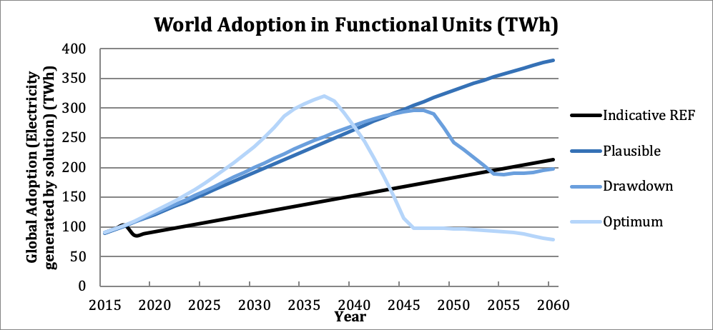

Figure 3.1 World Annual Adoption 2015-2060

Note: As waste diversion solutions are adopted at more aggressive levels in each scenario, less waste remains for the waste to energy solution. Therefore, the Optimum WTE scenario will have less global electricity generation in comparison to the Plausible Scenario.

## Climate Impacts

Below are the emissions results of the analysis for each scenario which include total emissions reduction and atmospheric concentration changes. For a detailed explanation of each result, please see the glossary (Section 6). Cumulative emissions reductions are mostly due to the avoidance of emissions from CH4, though also due to replacement of carbon-emitting fossil fuel sources. The Plausible Scenario results in the avoidance of 3.09 gigatons of carbon dioxide-equivalent greenhouse gas emissions between 2020-2050. Both the Drawdown and Optimum Scenarios are less ambitious in the growth of electricity generated from Waste to Energy as there is less waste available in each scenario. Therefore, the impacts on greenhouse gas emissions reductions over 2020-2050 is equivalent to 5.36 gigatons of carbon dioxide-equivalent for the Drawdown Scenario and a negative impact of 1.4 gigatons of carbon dioxide-equivalent for the Optimum Scenario in comparison to conventional technologies use. Tables 3.2 and 3.3. provide additional information on the climate impacts of the solution adoption.

Table 3.2 Climate Impacts

|  |  |  |  |
| --- | --- | --- | --- |
| **Scenario** | **Maximum Annual Emissions Reduction** | **Total Emissions Reduction** | **Emissions Reduction in 2050** |
| *(Gt CO2-eq/yr.)* | *Gt CO2-eq/yr. (2020-2050)* | *(Gt CO2-eq/year)* |
| ***Plausible*** | 0.16 | 3.09 | 0.16 |
| ***Drawdown*** | 0.24 | 5.36 | 0.11 |
| ***Optimum*** | 0.06 | -1.4 | 0.06 |

The solution was integrated with all other Project Drawdown solutions and may have different emissions results from the models. This is due to adjustments caused by interactions among solutions that limit full adoption (such as by feedstock or demand limits) or that limit the full benefit of some solutions (such as reduced individual solution impact when technologies are combined). After integration, the impact on emission reduction for this solution is 3.01 gigatons of carbon dioxide-equivalent in the Plausible scenario (PDS1), 5.27 gigatons of carbon dioxide-equivalent for the Drawdown Scenario and -1.4 gigatons of carbon dioxide-equivalent for the Optimum Scenario. Figure 3.2. show the world annual emissions reduction trajectories for the different scenarios for the long term.

Table 3.3 Impacts on Atmospheric Concentrations of CO2-eq

|  |  |  |
| --- | --- | --- |
| **Scenario** | **GHG Concentration Change in 2050** | **GHG Concentration Rate of Change in 2050** |
| *PPM CO2-eq (2050)* | *PPM CO2-eq change from 2049-2050* |
| **Plausible** | 0.25 | 0.01 |
| **Drawdown** | 0.43 | 0.00 |
| **Optimum** | -0.09 | 0.01 |

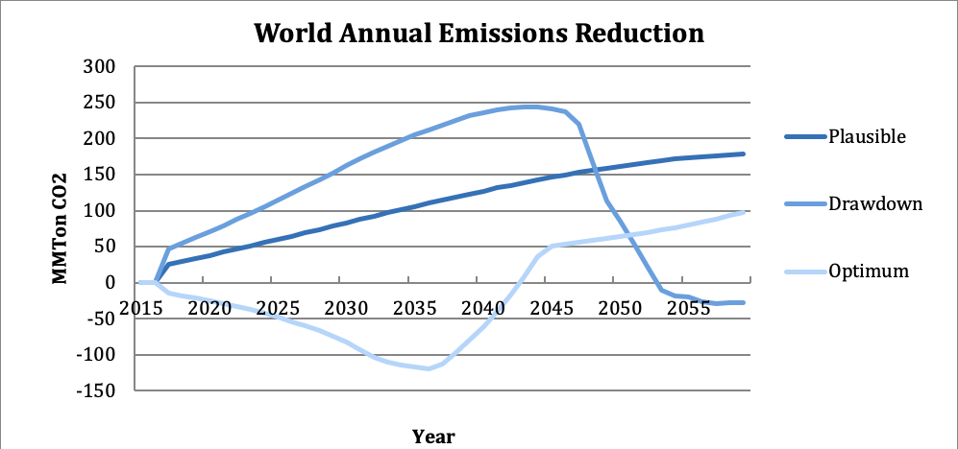

Figure 3.2 World AnnualGreenhouse Gas Emissions Reduction

## Financial Impacts

The financial impacts incurred by replacing conventional grid electricity sources with waste to energy powerplants in the Plausible scenario presents US$95.2 billion in marginal first costs and -US$33.07 billion of net operating cost savings are projected over the same period. PDS2 has US$76.09 billions of marginal first costs and over -US$32.59 billions of net operating savings, while PDS3 has US$40.88 billions of marginal first costs and over -US$23.61 billions of net operating savings. As stated before, in each scenario, more aggressive waste management solutions are being adopted, therefore leaving the waste to energy solution with less waste to generate electricity. Therefore, the Plausible Scenario results in higher costs due to higher volume of waste processing, while the Optimum scenario results in lower costs due to lower volume of waste.

The capital costs for PDS adoption of WTE systems will require significant investments, as the cumulative capital costs are over $304 billion under the Plausible Scenario, $279 billion under the Drawdown Scenario, and $263 billion for the Optimum Scenario. The learning rate used in this analysis lead to a continued but small decrease in the capital costs of WTE till 2050. Below in Table 3.4 are the financial results of the analysis for each scenario. For a detailed explanation of each result, please see the glossary (Section 6).

Table 3.4 Financial Impacts

|  |  |  |  |  |
| --- | --- | --- | --- | --- |
| **Scenario** | **Cumulative First Cost** | **Marginal First Cost** | **Net Operating Savings** | **Lifetime Cashflow Savings NPV (of All Implementation Units)** |
| *2015-2050 Billion USD* | *2015-2050 Billion USD* | *2020-2050 Billion USD* | *Billion USD* |
| **Plausible** | 304.25 | 95.20 | -33.07 | -20.14 |
| **Drawdown** | 278.94 | 76.09 | -32.59 | -20.59 |
| **Optimum** | 262.90 | 40.88 | -23.61 | 8.24 |

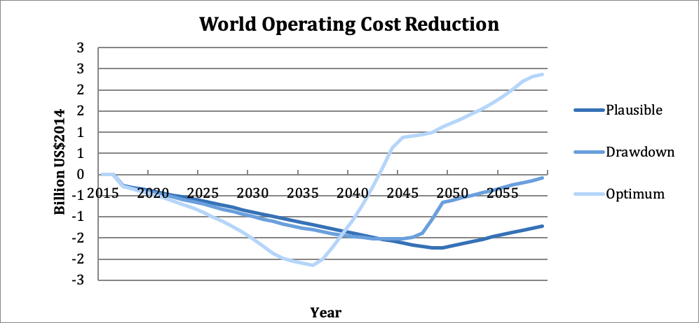

Figure 3.3 Operating Costs Over Time for the three PD scenarios

# Discussion

## Sensitivity Analysis

Although a sensitivity analysis was not conducted within the model, it is valuable to see how our chosen values would affect the results if they were changed as described in this section. When doing a sensitivity analysis it becomes apparent that the climate estimates are based on a large number of assumptions which have large consequences on overall climate mitigation output. The current default values used, as described elsewhere in this report are: MCF - 0.6, k-value - 0.09, DOCf - 0.5, and the GWP-100 value for CO2 equivalent for methane emissions, 28, is used. Figure 3.5 below shows the impact of changing even just one of these values, which is often significant.

Table 3.5 Financial Impacts - Climate Mitigation Estimates for Different Input Values

|  |  |  |
| --- | --- | --- |
|  | *Gt CO2/yr 2020-2050* | *ppm CO2-eq (2050)* |
| All Default | 0.949 | 0.08 |
| MCF – 1 | 1.576 | 0.14 |
| k-value - 0.03 | .135 | 0.01 |
| k-value - 0.2 | 1.604 | 0.14 |
| DOCf - 0.75 | 1.884 | 0.16 |
| GWP-20 (84) | 3.649 | 0.31 |

The Methane Correction Factor (MCF) of 1, indicates that 100% of the carbon in the waste will degrade anaerobically. The IPCC states that this is a valid figure to use for managed landfills, which is likely representative of many, but not all landfills which are likely to be replaced by WTE systems.

Changing the decay constant (k-value) also has a significant impact on total emissions savings. K-values are likely to change significantly with climate, waste composition, and landfill design. Rapidly degradable wastes such as food waste, and high moisture conditions are likely to degrade more quickly have k-values closer to 0.2. In turn, dry sites with slowly degradable waste such as wood and paper are likely to have k-values closer to 0.01. Therefore, considering the significant impact that k-value has on the overall emissions output, these factors should be considered carefully when assessing the value of WTE under particular conditions.

The DOCf measures the percentage of all carbon in the waste which decomposes. The increased value of 0.75 used in this sensitivity analysis represents replacement of a landfill which is semi-aerobic, as opposed to anaerobic conditions used in the original assumption of a DOCf of 0.5. Therefore, a DOCf this high is unlikely to be seen with high MCF values. Finally, the single most significant variable is which GWP value is used. If GWP-20 is used instead of the GWP-100 currently used in the model, emissions savings increase by almost four times. In general, the large variability in emissions savings based on which values are chosen demonstrates the importance of assessing each WTE plant based on local conditions.

## Limitations

This study models scenarios where WTE could significantly reduce future GHG emissions and help draw down the amount of carbon in the atmosphere by 0.25 ppm by 2050. This is less than the true total amount possible, as it was chosen to use reference climate mitigation scenarios estimations for WTE adoption, under the assertion that ambitious adoption of WTE is less ideal than diverting waste to many alternate disposal options.

Overall, WTE solutions are a net benefit for the climate. From a financial perspective, while some up-front costs are required for landfill gas to electricity technologies, there is only a small long term cost to these solutions. As mentioned throughout the report, high WTE capital costs present a significant challenge. With cumulative first costs of $304 billion, and a $33 billion cumulative net operating cost, WTE does not present a particularly compelling financial case. This is nothing new for WTE, which thrives primarily in environments where both waste disposal fees and electricity costs are high. While it is clearly a ‘second-best’ waste management strategy, as long as landfills are being created it is still a viable and important solution for climate mitigation.

## Benchmarks

Table 4.1 depicts a benchmark of Project Drawdown results for 2050 on the three developed scenarios to other six publicly available scenarios from IEA (2017) and Greenpeace (2015). The benchmarked results account for total electricity generation projected for the year 2050 from Biomass and Renewable Waste, while project Drawdown results account for the waste to energy solution results. There are no direct comparable benchmarks to the waste to energy solution, therefore these references can be used to bound the adoption of the waste to energy solution among other solutions. The values reported below are raw data points from the sources.

*Table 4.1 Benchmarks*

|  |  |  |
| --- | --- | --- |
| **Source and Scenario** | **Electricity Generation in 2050 (TWh)** | **Market Share in 2050 (%)** |
| **Project Drawdown – Plausible Scenario (PDS1)** | **329.81** | **0.72%** |
| **Project Drawdown – Drawdown Scenario (PDS2)** | **242.06** | **0.34%** |
| **Project Drawdown – Optimum Scenario (PDS3)** | **96.86** | **0.14%** |
| IEA Energy Technologies Perspectives (2017) – World Reference Technology Scenario | 2,198 | 4.68% |
| IEA Energy Technologies Perspectives (2017) – 2DS | 2,939 | 6.91% |
| IEA Energy Technologies Perspectives (2017) – Beyond 2DS | 3,589 | 8.10% |
| Greenpeace Energy [R]evolution (2015) – Reference Scenario *(includes Electricity + CHP)* | 1,577 | 11.30% |
| Greenpeace Energy [R]evolution (2015) – Energy Revolution Scenario *(includes Electricity + CHP)* | 3,039 | 24.57% |
| Greenpeace Energy [R]evolution (2015) – Advanced Energy Revolution Scenario *(includes Electricity + CHP)* | 3,193 | 19.83% |

# References

Abdel-Aziz, Amr, Adolf Acquaye, Julian Allwood, Jean-Paul Ceron, Yong Geng, Haroon Kheshgi, Alessandro Lanza, et al. (2014). *Industry*. In Climate Change 2014: Mitigation of Climate Change. Contribution of Working Group III to the Fifth Assessment Report of the Intergovernmental Panel on Climate Change, 739–810. United Kingdom and New York, NY, USA: Cambridge University Press.

Ajaybhai, K. K., Pandey, K.K. 2014. Waste to Energy Status in India: A Short Review. *Renewable and Sustainable Energy Reviews 31 (March): 113–20*. doi:10.1016/j.rser.2013.11.020.

AMPERE. (2014). *AMPERE Database, Regions Definitions, EU FP7 AMPERE Project*. Retrieved from: https://secure.iiasa.ac.at/web-apps/ene/AMPEREDB/dsd?Action=htmlpage&page=about#regiondefs

Bahor, B., M. Van Brunt, J. Stovall, and K. Blue. (2009). Integrated Waste Management as a Climate Change Stabilization Wedge. *Waste Management & Research 27 (9): 839–49.*

Bhada, P. (2007). Feasibility Analysis of Waste-to-Energy as a Key Component of Integrated Solid Waste Management in Mumbai, India. Columbia University. http://www.mumbaidp24seven.in/reference/Feasibility_Analysis_of_waster_to_Energy_Bhada_Thesis.pdf.

Bogner, J., and E. Matthews. (2003). Global Methane Emissions from Landfills: New Methodology and Annual Estimates 1980–1996. *Global Biogeochemical Cycles 17 (2): 1065.* doi:10.1029/2002GB001913.

Braw, Elizabeth. (2015). *Dirty Power: Sweden Wants Your Garbage for Energy.* Al Jazeera America. March 27. http://america.aljazeera.com/articles/2015/3/27/sweden-wants-your-garbage-for-energy.html.

Chandel, Munish, Gabriel Kwok, Robert Jackson, and Lincol Pratson (2012). The potential of waste-to-energy in reducing GHG emissions. *Carbon Management* 3 (2): 133-144.

Cheng, Hefa, and Yuanan Hu. (2010). Municipal Solid Waste (MSW) as a Renewable Source of Energy: Current and Future Practices in China. *Bioresource Technology 101 (11): 3816–24.* doi:10.1016/j.biortech.2010.01.040.

Cherubini, F., Bargigli, S., Ulgiati. S. (2009). Life Cycle Assessment (LCA) of Waste Management Strategies: Landfilling, Sorting Plant and Incineration. *Energy 34 (12): 2116–23.* doi:10.1016/j.energy.2008.08.023.

Cleary, J. (2009). Life Cycle Assessments of Municipal Solid Waste Management Systems: A Comparative Analysis of Selected Peer-Reviewed Literature. *Environment International 35 (8): 1256–66.* doi:10.1016/j.envint.2009.07.009.

Danish Energy Agency and Energynet. (2012). Technology Data for Energy Plants Generation of Electricity and District Heating, Energy Storage and Energy Carrier Generation and Conversion. Danish Energy Agency and Energinet.dk. Retrieved from: https://www.energinet.dk/SiteCollectionDocuments/Danske%20dokumenter/Forskning/Technology_data_for_energy_plants.pdf

Dhabi.

Di Maria, F., Micale. C. (2015). Life Cycle Analysis of Incineration Compared to Anaerobic Digestion Followed by Composting for Managing Organic Waste: The Influence of System Components for an Italian District. *The International Journal of Life Cycle Assessment 20 (3): 377–88.* doi:10.1007/s11367-014-0833-z.

DOE (2019). *Waste-to-Energy from Municipal Solid Wastes.* US Department of Energy: Office of Energy Efficiency and Renewable Energy.

Duffy, D. (2015). *Landfill Economics Part 2: Getting Down to Business – Part 2.* Forester Network. Retrieved from April 6, 2015. http://foresternetwork.com/daily/waste/landfill-management/landfill-economics-part-ii-getting-down-to-business-part-ii/.

EC, (2016). *Circular Economy Strategy - Environment.* European Commission Accessed November 15, 2016. http://ec.europa.eu/environment/circular-economy/index_en.htm.

Ecofys (2018). *Energy transition within 1.5ºC.* A disruptive approach to 100% decarbonization of the global energy system by 2050. Ecofys- A Navigant Company. Retrieved from: <https://www.navigant.com/-/media/www/site/downloads/energy/2018/navigant2018energytransitionwithin15c.pdf>

EIA. (2014). Average Operating Heat Rate for Selected Energy Sources. Environmental Information Agency. http://www.eia.gov/electricity/annual/html/epa_08_01.html.

Equinor (2018). *Energy Perspectives 2018, Long-term macro and market outlook.* Equinor. Available at: <https://www.equinor.com/en/news/07jun2018-energy-perspectives.html>

EPA (2020). *Inventory of US Greenhouse Gas Emissions and Sinks 1990-2018*. United States Envrionmental Protection Agency.

Eriksson, O., Finnveden, G., Ekvall, T., Björklund, A. (2007). Life Cycle Assessment of Fuels for District Heating: A Comparison of Waste Incineration, Biomass- and Natural Gas Combustion. *Energy Policy 35 (2): 1346–62*. doi:10.1016/j.enpol.2006.04.005.

Ferris, D. (2013). *Out of India’s Trash Heaps, A Controversy on Incineration.* Yale Environment 360. http://e360.yale.edu/feature/out_of_indias_trash_heaps_a_controversy_on_incineration/271/.

Finnveden, G., Johansson, J., Lind, P., Moberg, Å. (2000). *Life Cycle Assessments of Energy from Solid Waste.* Stockholms Universitet.

Funk, K., Milford, J., Simpkins, T. (2013). *Waste Not, Want Not: Analysing the Economic and Environmental Viability of Waste-to-Energy (WTE) Technology for Site-Specific Optimization of Renewable Energy Options.* National Renewable Energy Laboratory. http://wtert-ghana.tiswm.com/files/Waste-to-Energy_Technology_for_site-specific_optimization.pdf.

Gentil, E. (2013). *Municipal Waste Management in France.* European Environment Agency.

Global Alliance for Incinerator Alternatives. (2014). *To the Attention of the IPCC WG III,* Retrieved April 13 2016

Global Alliance of Waste Pickers. (2014). *Mission.* Retrieved March 13, 2016. http://globalrec.org/mission/

Global Market Insights. (2016). Waste to Energy (WTE) Market Size, Application Potential, Competitive Market Share & Forecast, 2016-2024.

Grand View Research. (2015). *Waste To Energy (WTE) Market Analysis.* Retrieved from http://www.grandviewresearch.com/industry-analysis/waste-to-energy-technology-industry.

Greenpeace. (2015). *World Energy [R]evolution, a sustainable world energy outlook.* Retrieved from: http://www.greenpeace.org/international/Global/international/publications/climate/2015/Energy-Revolution-2015-Full.pdf

Hayward, J. A., Graham, P. W. (2017). *Electricity generation technology cost projections: 2017-2050*. Commonwealth Scientific and Industrial Research Organisation (CSIRO). Retrieved from <https://publications.csiro.au/rpr/pub?pid=csiro:EP178771>

Hayward, J., Graham, P.W. (2013). A global and local endogenous experience curve model for projecting future uptake and cost of electricity generation technologies. *Energy Economics, 40, 537-548.* <https://doi.org/10.1016/j.eneco.2013.08.010>

Health Protection Agency. (2009). T*he Impact on Health of Emissions to Air from Municipal Waste Incinerators.* UK Health Protection Agency.

Hondo, H. (2005). Life cycle GHG emission analysis of power generation systems: Japanese case. *Energy 30 - 2042–2056.* Retrieved from http://www.univie.ac.at/photovoltaik/umwelt/LCA_japanstudy.pdf

Hoornweg, D., Bhada-Tata, P.( 2012). *What a Waste: A Global Review of Solid Waste Management.* World Bank.

Hoornweg, D., Bhada-Tata, P., Kennedy, C. (2015). Peak Waste: When Is It Likely to Occur? *Industrial Ecology 19 (1): 117–28.*

Hoornweg, D., Lam, P., Chaudhry, M. (2005). *Waste Management in China: Issues and Recommendations.* 9. Urban Development Working Papers. East Asia Infrastructure Department, The World Bank.

IEA and NEA (2010). *Projected Costs of Generating Electricity – edition 2010.* Organisation for Economic Co-operation and Development - International Energy Agency and Nuclear Energy Agency. France. Retrieved from http://www.worldenergyoutlook.org/media/weowebsite/energymodel/ProjectedCostsofGeneratingElectricity2010.pdf

IEA and NEA (2015). *Projected Costs of Generating Electricity – edition 2015.* Organisation for Economic Co-operation and Development - International Energy Agency and Nuclear Energy Agency. France. Retrieved from https://www.oecd-nea.org/ndd/pubs/2015/7057-proj-costs-electricity-2015.pdf

IEA. (2016a). Annex I: Municipal solid waste potential in cities. Retrieved November 14, 2016, from http://www.iea.org/media/etp/etp2016/AnnexI_MSWpotential_web.pdf

IEA. (2016b). *Energy Technology Perspectives 2016 - Towards Sustainable Urban Energy Systems*. International Energy Agency. OECD/IEA, Paris, France. Retrieved from: <https://www.iea.org/publications/freepublications/publication/EnergyTechnologyPerspectives2016_ExecutiveSummary_EnglishVersion.pdf>

IEA. (2017). *Energy Technology Perspectives 2017 - Catalysing Energy Technology Transformations.* International Energy Agency (IEA). Retrieved from: <https://www.iea.org/etp/>

IEA. (2018). *World Energy Outlook 2018.* International Energy Agency (IEA). Retrieved from: <https://webstore.iea.org/world-energy-outlook-2018>

IEA (2019). Energy Prices and Taxes – Quarterly Statistics – First Quarter 2019. International Energy Agency. OECD/IEA, Paris.

IEEJ. (2018). *IEEJ Outlook 2019 – Energy transition and a thorny oath for 3E challenges.* The Institute of Energy Economics Japan. Available at: <https://eneken.ieej.or.jp/data/8122.pdf>

IPCC (2007a). *Solid Waste Disposal.* In 2006 IPCC Guidelines for National Greenhouse Gas Inventories. Vol. 5. Waste. Retrieved from: <http://www.ipcc-nggip.iges.or.jp/public/2006gl/pdf/5_Volume5/V5_3_Ch3_SWDS.pdf>.

IPCC (2007b). *Stationary Combustion.* In 2006 IPCC Guidelines for National Greenhouse Gas Inventories. Vol. 2. Energy. Retrieved from: http://www.ipcc-nggip.iges.or.jp/public/2006gl/pdf/2_Volume2/V2_2_Ch2_Stationary_Combustion.pdf.

IPCC. (2006a). *Incineration and Open Burning of Waste.* In 2006 IPCC Guidelines for National Greenhouse Gas Inventories. Vol. 5. Waste. Retrieved from: http://www.ipcc-nggip.iges.or.jp/public/2006gl/pdf/5_Volume5/V5_5_Ch5_IOB.pdf.

IPCC. (2006b). *Waste Generation, Composition, and Management Data.* In 2006 IPCC Guidelines for National Greenhouse Gas Inventories. Vol. 5. Waste. Retrieved from: http://www.ipcc-nggip.iges.or.jp/public/2006gl/pdf/5_Volume5/V5_2_Ch2_Waste_Data.pdf.

IPCC. (2006c). *Stationary Combustion* In 2006 IPCC Guidelines for National Greenhouse Gas Inventories. Vol. 2. Energy. http://www.ipcc-nggip.iges.or.jp/public/2006gl/pdf/2_Volume2/V2_2_Ch2_Stationary_Combustion.pdf

IRENA.(2012). *Biomass for Power Generation.* In Renewable Energy Technologies: Cost Analysis Series. Vol. 1. Power Sector. Retrieved from: https://www.irena.org/DocumentDownloads/Publications/RE_Technologies_Cost_Analysis-BIOMASS.pdf

IRENA (2019). *Renewable Energy Statistics 2019*, International Renewable Energy Agency, Abu Dhabi.

IRENA. (2019). *Global energy transformation:* The REmap transition pathway (Background report to 2019 edition), International Renewable Energy Agency, Abu Dhabi.

Kaza, Silpa, Lisa Yao, Perinaz Bhada-Tata, and Frank Van Woerden. (2018). *What a Waste 2.0: A Global Snapshot of Solid Waste Management to 2050.* Urban Development Series. Washington, DC: World Bank. doi:10.1596/978-1-4648 -1329-0.

Letter to Joe Goffman, EPA Senior Counsel. 19 June 2014. http://www.caryinstitute.org/sites/default/files/public/downloads/news/2014_06_epa_biomass_carbon.pdf

Masanet, E., Chag, Y., Gopal, A., Larsen, P., Morrow III, W., Sathre, R., Shehabi, A., Zhai, P. (2013). Life cycle assessment of electric power systems. *Annu. Rev. Environ. Resour, 38:107–36.* Doi: 10.1146/annurev-environ-010710-100408

Matthews, E., and N. J. Themelis. (2007). *Potential for Reducing Global Methane Emissions from Landfills, 2000-2030*. In Proceedings of International Landfill Symposium, Sardinia, Italy. http://www.seas.columbia.edu/earth/wtert/sofos/Matthews_Themelis_Sardinia2007.pdf.

Maya, D. M., Angie Lizeth Espinos Sarmiento, Cristina Aparecida Vilas Boas De Sales Oliveira, Electo Eduardo Silva Lora, and Rubenildo Vieira Andrade. (2016). *Gasification of Municipal Solid Waste for Power Generation in Brazil, a Review of Available Technologies and Their Environmental Benefits.* *Journal of Chemistry and Chemical Engineering, 10 (6).* doi:10.17265/1934-7375/2016.06.001

Moberg, Å., Göran Finnveden, Jessica Johansson, and Per Lind. (2005). Life Cycle Assessment of Energy from Solid Waste—part 2: Landfilling Compared to Other Treatment Methods. *Journal of Cleaner Production 13 (3): 231–40*. doi:10.1016/j.jclepro.2004.02.025.

Modak, P. (2011). *Waste: Investing in Energy and Resource Efficiency.* In Towards a Green Economy. United Nations Environment Programme.

Monni, Suvi, Riitta Pipatti, Antti Lehtila, Ilkka Savolainen, and Sanna Syri. (2006). *Global Climate Change Mitigation Scenarios for Solid Waste Management.* VTT Publications 603. Espoo. https://www.vtt.fi/inf/pdf/publications/2006/P603.pdf

Mühle, S., I. Balsam, and C.R. Cheeseman. (2010). Comparison of Carbon Emissions Associated with Municipal Solid Waste Management in Germany and the UK. *Resources, Conservation and Recycling 54 (11): 793–801.* doi:10.1016/j.resconrec.2009.12.009.

Navigant Research. (2012). *Global Waste-to-Energy Market to Reach $29.2 Billion by 2022*. Navigant Research. March 23. http://www.navigantresearch.com/newsroom/global-waste-to-energy-market-to-reach-29-2-billion-by-2022.

NETL (2013). *Power Generation Technology Comparison from a Life Cycle Perspective.* National Energy Technology Laboratory. Retrieved from <https://www.netl.doe.gov/File%20Library/Research/Energy%20Analysis/Life%20Cycle%20Analysis/Technology-Assessment-Compilation-Report.pdf>

Panepinto, Deborah, Vita Tedesco, Enrico Brizio, and Giuseppe Genon. (2014). Environmental Performances and Energy Efficiency for MSW Gasification Treatment. *In Waste and Biomass Valorization 6.1*

Pfaff-Simoneit, W. (2012). *Entwicklung eines sektoralen Ansatzes zum Aufbau von nachhaltigen Abfallwirtschaftssystemen in Entwicklungsländern vor dem Hintergrund von Klimawandel und Ressourcenverknappung.* Universität Rostock.

Ragnauth, S., J. Petrusa, J. Alsalam, and R. Beach. (2013)*. Global Mitigation of Non-CO2 Greenhouse Gases: 2010-2030*. 430-R-13-011. Washington, DC: Environmental Protection Agency.

Ram M., Bogdanov D., Aghahosseini A., Gulagi A., Oyewo A.S., Child M., Caldera U., Sadovskaia K., Farfan J., Barbosa LSNS., Fasihi M., Khalili S., Dalheimer B.,Gruber G., Traber T., De Caluwe F., Fell H.-J., Breyer C. (2019). *Global Energy System based on 100% Renewable Energy –Power, Heat, Transport and Desalination Sectors.* Study by Lappeenranta University of Technology and Energy Watch Group, Lappeenranta, Berlin, March 2019. Available at: <http://energywatchgroup.org/wp-content/uploads/EWG_LUT_100RE_All_Sectors_Global_Report_2019.pdf>

Schneider, D., D. Loncar, Z. Bogdan. (2010). *Cost Analysis of Waste-to-Energy Plant.* In Strojarstvo

Simoes, S., Nijs, W., Ruiz, P., Sgobbi, A., Radu, D., et al. (2013). *The JRC-EU-TIMES model - Assessing the long-term role of the SET Plan Energy Technologies.* Joint Research Center. Publications Office of the European Union. Retrieved from <http://publications.jrc.ec.europa.eu/repository/handle/JRC85804>

Themelis, Nickolas J., and Priscilla A. Ulloa. (2007). Methane Generation in Landfills. *Renewable Energy 32 (7): 1243–57.* doi:10.1016/j.renene.2006.04.020.

Themelis, Nickolas J., Maria Elena Diaz Barriga, Paula Estevez, and Maria Gaviota Velasco. (2013). *Guidebook for the Application of Waste to Energy Technologies in Latin America and the Caribbean.*

United Nations Environment Program. (2015). *Global Waste Management Outlook.* International Solid Waste Association

United Nations, Department of Economic and Social Affairs. (2013). *World Population Prospects: The 2012 Revision, DVD Edition.* United Nations. <http://esa.un.org/wpp/>.

United Nations, Department of Economic and Social Affairs, Population Division (2018). *World Urbanization Prospects 2018.*

US EIA. (2013). *Updated Capital Cost Estimates for Utility Scale Electricity Generating Plants. U.S.* Department of Energy. https://www.eia.gov/outlooks/capitalcost/pdf/updated_capcost.pdf

Vision Gain. (2014). *Waste to Energy (WTE) Market Forecast 2014-2024.* Retrieved from https://www.visiongain.com/report_license.aspx?rid=1194.

Whitman, Adrian, Javier Esparrago, Tobias Rinke, Iana Arkhipova. (2006). *Renewable Statistics 2016*. International Renewable Energy Agency.

World Bank. (1999). *World Bank Technical Guidance Report-Waste Incineration - Municipal SW*. Retrieved from http://web.mit.edu/urbanupgrading/urbanenvironment/resources/references/pdfs/MunicipalSWIncin.pdf.

World Energy Council. (2013a). *Waste to Energy. World Energy Resources.* World Energy Council. Retrieved from: http://www.worldenergy.org/wp-content/uploads/2013/10/WER_2013_7b_Waste_to_Energy.pdf.

World Energy Council. (2013b). *World Energy Perspective: Cost of Energy Technologies.* <https://www.worldenergy.org/wp-content/uploads/2013/09/WEC_J1143_CostofTECHNOLOGIES_021013_WEB_Final.pdf>

# Glossary

**Adoption Scenario** – the predicted annual adoption over the period 2015 to 2060, which is usually measured in **Functional Units**. A range of scenarios is programmed in the model, but the user may enter her own. Note that the assumption behind most scenarios is one of growth. If for instance, a solution is one of reduced heating energy usage due to better insulation, then the solution adoption is translated into an increase in the use of insulation. There are two types of adoption scenarios in use: **Reference (REF)** where global adoption remains mostly constant, and **Project Drawdown Scenarios (PDS)** which illustrate the high growth of the solution.

**Approximate PPM Equivalent** – the reduction in the atmospheric concentration of CO2 (in **PPM**) that is expected to result if the **PDS Scenario** occurs. This assumes a discrete avoided pulse model based on the Bern Carbon Cycle model.

**Average Abatement Cost** – the ratio of the present value of the solution (**Net** **Operating Savings** minus **Marginal First Costs**) and the **Total Emissions Reduction**. This is a single value for each solution for each **PDS Scenario** and is used to build the characteristic “*Marginal Abatement Cost*” curves when Average Abatement Cost values for each solution are ordered and graphed.

**Average Annual Use** – the average number of functional units that a single implementation unit typically provides in one year. This is usually a weighted average for all users according to the data available. For instance, the total number of passenger-km driven by a hybrid vehicle in a year depends on the country and the typical number of occupants. We take global weighted averages for this input. This is used to estimate the **Replacement Time**.

**Cumulative First Cost** – the total **First Cost** of solution **Implementation Units** purchased in the **PDS Scenario** in the analysis period. The number of solution implementation units that are available to provide emissions reduction during the analysis period is dependent on the units installed prior to the analysis period, and hence all implementation units installed after the base year are included in the cumulative first costing (that is 2015-2050).

**Direct Emissions** – emissions caused by the operation of the solution, which are typically caused by the lifetime use of the solution. They should be entered into the model normalized per functional unit.

**Discount Rate**- the interest rate used in discounted cash flow (DCF) analysis to determine the present value of future cash flows. The discount rate in DCF analysis takes into account, not just the time value of money, but also the risk or uncertainty of future cash flows; the greater the uncertainty of future cash flows, the higher the discount rate. Most importantly, the greater the discount rate, the more the future savings are devalued (which impacts the financial but not the climate impacts of the solution).

**Emissions** **Factor**– the average normalized emissions resulting from consumption of a unit of electricity across the global grid. Typical units are kg CO2e/kWh.

**First Cost**- the investment cost per **Implementation Unit** which is essentially the full cost of establishing or implementing the solution. This value, measured in 2014$US, is only accurate to the extent that the cost-based analysis is accurate. The financial model assumes that the first cost is made entirely in the first year of establishment and none thereafter (that is, no amortization is included). Thus, both the first cost and operating cost are factored in the financial model for the first year of implementation, all years thereafter simply reflect the operating cost until replacement of the solution at its end of life.

**Functional Unit** – a measurement unit that represents the value, provided to the world, of the function that the solution performs. This depends on the solution. Therefore, LED Lighting provides petalumen-hours of light, Biomass provides tera-watt-hours of electricity and high-speed rail provides billions of passenger-km of mobility.

**Grid Emissions** – emissions caused by the use of the electricity grid in supplying power to any operation associated with a solution. They should be in the units described below each variable entry cell. Drawdown models assume that the global electric grid, even in a Reference Scenario, is slowly getting cleaner and that emissions factors fall over time resulting in lower grid emissions for the same electricity demand.

**Implementation Unit** – a measurement unit that represents how the solution practice or technology will be installed/setup and priced. The implementation unit depends on the solution. For instance, implementing electric vehicles (EV) is measured according to the number of actual EV’s in use, and adoption of Onshore Wind power is measured according to the total terawatts (TW) of capacity installed worldwide.

**Indirect Emissions** – emissions caused by the production or delivery or setup or establishment of the solution in a specified area. These are NOT caused by day to day operations or growth over time, but they should be entered into the model normalized on a per functional unit or per implementation unit basis.

**Learning Rate/Learning Curve** - Learning curves (sometimes called experience curves) are used to analyze a well-known and easily observed phenomenon: humans become increasingly efficient with experience. The first time a product is manufactured, or a service is provided, costs are high, work is inefficient, quality is marginal, and time is wasted. As experienced is acquired, costs decline, efficiency and quality improve, and waste is reduced. The model has a tool for calculating how costs change due to learning. A 2% learning rate means that the cost of producing a good drops by 2% every time total production doubles.

**Lifetime Capacity** – this is the total average functional units that one implementation unit of the solution or conventional technology or practice can provide before replacement is needed. All technologies have an average lifetime usage potential, even considering regular maintenance. This is used to estimate the **Replacement Time**. and has a direct impact on the cost to install/acquire technologies/practices over time. E.g. solar panels generate, on average, a limited amount of electricity (in TWh) per installed capacity (in TW) before a new solar panel must be purchased. Electric vehicles can travel a limited number of passenger kilometers over its lifetime before needing to be replaced.

**Lifetime Operating Savings**–the operating cost in the PDS versus the REF scenarios over the lifetime of the implementation units purchased during the model period regardless of when their useful life ends.

**Lifetime Cashflow NPV**-the present value (PV) of the net cash flows (PDS versus REF) in each year of the model period (2015-2060). The net cash flows include net operating costs and first costs. There are two results in the model: Lifetime Cashflow NPV for a Single **Implementation Unit**, which refers to the installation of one **Implementation Unit**, and Lifetime Cashflow NPV of All Units, which refers to all **Implementation Units** installed in a particular scenario. These calculations are also available using profit inputs instead of operating costs.

**Marginal First Cost** – the difference between the **First Cost** of all units (solution and conventional) installed in the **PDS Scenario** and the **First Cost** of all units installed in the **REF Scenario** during the analysis period. No discounting is performed. The number of solution implementation units that are available to provide emissions reduction during the analysis period is dependent on the units installed prior to the analysis period, and hence all implementation units installed after the base year are included in the cumulative first costing (that is 2015-2050).

**Net Annual Functional Units (NAFU)** – the adoption in the PDS minus the adoption in the REF in each year of analysis. In the model, this represents the additional annual functional demand captured either by the solution in the **PDS Scenario** or the conventional in the **REF Scenario**.

**Net Annual Implementation Units (NAIU)** – the number of **Implementation Units** of the solution that are needed in the PDS to supply the **Net Annual Functional Units (NAFU).** This equals the adoption in the PDS minus the adoption in the REF in each year of analysis divided by the average annual use.

**Net Operating Savings** – The undiscounted difference between the operating cost of all units (solution and conventional) in the **PDS Scenario** minus that of all units in the **REF Scenario**.

**Operating Costs** – the average cost to ensure the operation of an activity (conventional or solution) which is measured in 2014$US/**Functional Unit**. This is needed to estimate how much it would cost to achieve the adoption projected when compared to the **REF Case**. Note that this excludes **First Costs** for implementing the solution.

**Payback Period** – the number of years required to pay all the **First Costs** of the solution using **Net Operating Savings**. There are four specific metrics each with one of **Marginal First Costs** or **First Costs** of the solution only combined with either discounted or non-discounted values. All four are in the model. Additionally, the four outputs are calculated using the increased profit estimation instead of **Net Operating Savings**.

**PDS/ Project Drawdown Scenario** – this is the high growth scenario for the adoption of the solution.

**PPB/ Parts per Billion** – a measure of concentration for atmospheric gases. 10 million PPB = 1%.

**PPM/ Parts per Million** – a measure of concentration for atmospheric gases. 10 thousand PPM = 1%.

**REF/ Reference Scenario** – this is the low growth scenario for the adoption of the solution against which all **PDS scenarios** are compared.

**Replacement Time**- the length of time in years, from installation/acquisition/setup of the solution through usage until a new installation/acquisition/setup is required to replace the earlier one. This is calculated as the ratio of **Lifetime Capacity** and the **Average Annual Use**.

**TAM/ Total Addressable Market** – represents the total potential market of functional demand provided by the technologies and practices under investigation, adjusting for estimated economic and population growth. For this solutions sector, it represents the world and regional total addressable markets for electricity generation technologies in which the solutions are considered.

**Total Emissions Reduction** – the sum of the grid, fuel, indirect, and other direct emissions reductions over the analysis period. The emissions reduction of each of these is the difference between the emissions that would have resulted in the **REF Scenario** (from both solution and conventional) and the emissions that would result in the **PDS Scenario**. These may also be considered as “emissions avoided” as they may have occurred in the REF Scenario, but not in the PDS Scenario.

**Transition solutions** - are considered till better technologies and less impactful are more cost-effective and mature.

**TWh/ Terawatt-hour** – A unit of energy equal to 1 billion kilowatt-hours.

1. Current adoption is defined as the amount of functional demand supplied by the solution in 2018. This study uses 2014 as the base year due to the availability of global adoption data for all Project Drawdown solutions evaluated
2. In some cases, the low boundary is negative for a variable that can only be positive, and in these cases the lowest collected data point is used as the “low” boundary.
3. All monetary values are presented in US$2014